Sumud Flotilla Intercepted Before Reaching Gaza
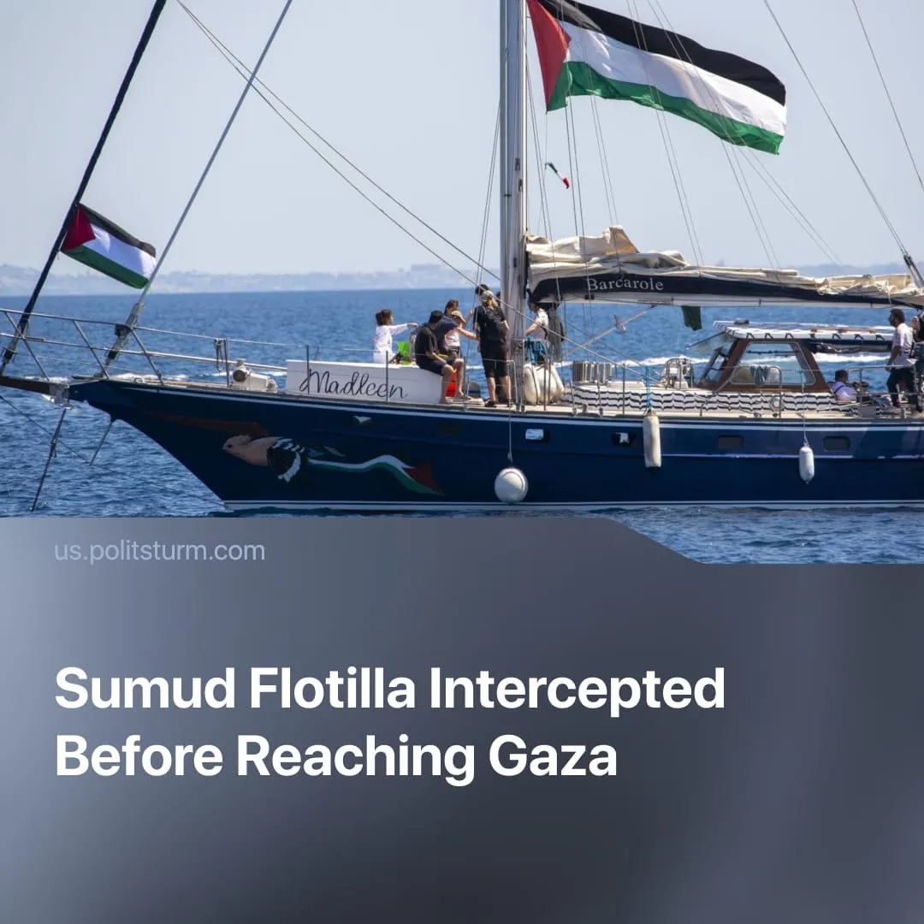

Original article
2025-10-11
1 min read

The ‘Sumud flotilla’ led by Greta Thunberg failed to reach Gaza. Like all previous attempts, it could not influence the conflict’s outcome and delivered no practical aid.
Details. The Global Sumud Flotilla, led by Greta Thunberg and other environmental and peace organisations, was an international convoy of ~50 vessels and 500 activists that departed Turkey in late September 2025 to “break the siege” and deliver a “message.”
► With just ~300 tons of aid, the flotilla would have barely dented Gaza’s catastrophic shortages, where millions depend on tens of thousands of tons of food, fuel, and medicine each month.
► Ultimately, it was intercepted by the Israeli Navy. Dozens of activists were detained, including Thunberg, before being deported or held for questioning. Some reported mistreatment, including beatings and verbal abuse, which Israeli authorities denied.
► Israeli officials justified the interception by citing the blockade’s legality under “security concerns,” offering to transfer the aid through official UN-approved crossings instead. While some European figures voiced concern, no government backed the flotilla. Spanish and Italian vessels briefly escorted it before Italy’s PM Giorgia Meloni ordered her country’s ships to withdraw from the mission.
Context. The ‘Sumud flotilla’, like all previous missions, was an adventurist spectacle that neither alleviated Gaza’s suffering nor influenced the conflict’s outcome. With Israel’s full naval control and Western backing, such actions were militarily and politically impossible — every flotilla has been intercepted without exception, altering nothing in policy or blockade.
► Adventurist attempts to break Gaza’s siege by sea have occurred regularly since 2010, when the Mavi Marmara flotilla ended in a deadly Israeli raid that killed 10 Turkish activists. Since then, similar efforts have been fully intercepted every time.
► Israel maintains total naval control over Gaza’s 40-kilometre coastline. The blockade, in place since 2007 and enforced jointly with Egypt, makes any foreign attempt to deliver aid by sea impossible.
For a full breakdown of Gaza’s two years of war, see our longer article.

Original article

