Study Exposes Income and Race Discrimination in Boston Housing Market
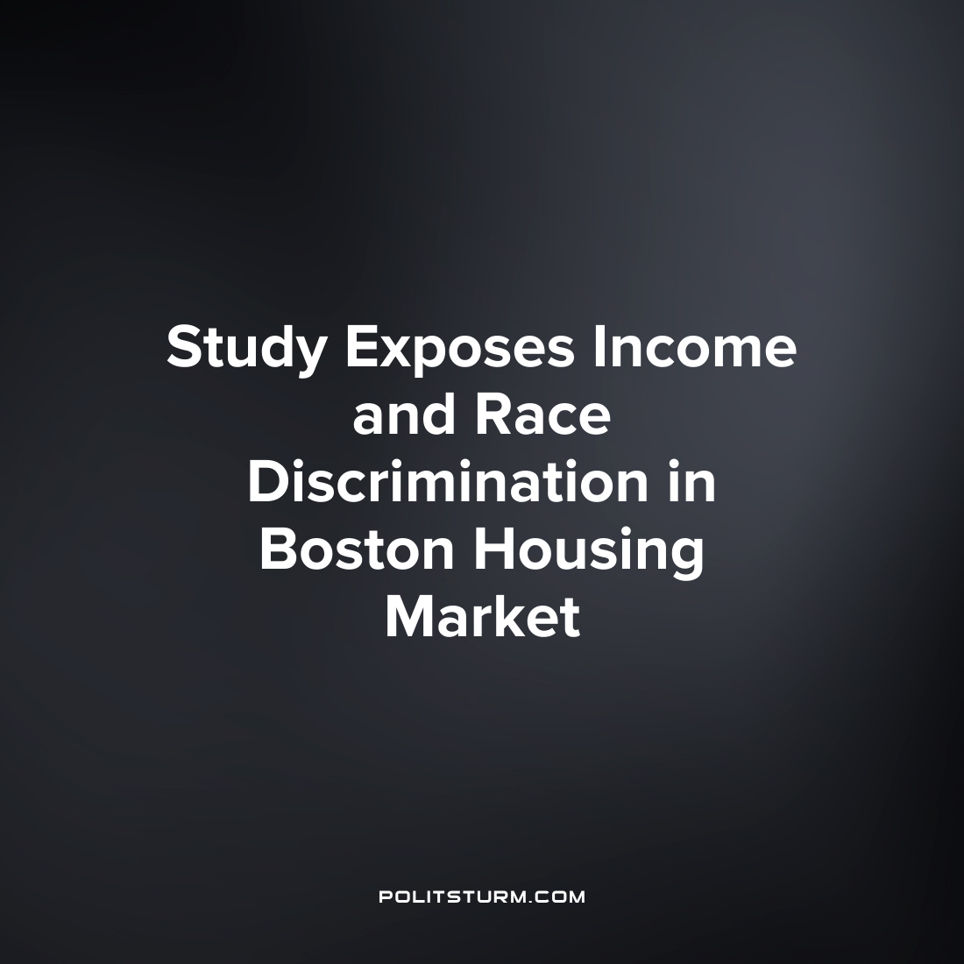

Original article
2022-07-12
1 min read

A study conducted by Suffolk University sought to investigate and gather data on race-based and voucher-based discrimination in the Boston-area rental housing market. The study gathered information on the behavior of rental agents and property owners including whether renters could make appointments to see an apartment, were offered rental applications, etc.
The testing uncovered that in 86% of the tests applications were discriminated against if they utilized Section 8 vouchers. Section 8 is a subsidy program in which a portion of the rent paid to the landlord is subsidized with the difference being paid by the renter.
There was also discrimination with respect to race as there was evidence for race-based discrimination in 71% of the tests.
“These results are disheartening. Housing discrimination based on race has been illegal for well over 150 years at the federal level. It is also illegal in Massachusetts to discriminate against a person based on race or because they have a housing voucher. Providing housing for profit is a business and those in business have an obligation to obey relevant laws in the practice of that business. Nevertheless, we found evidence of discrimination across a variety of property types, including owner-occupied buildings and stand-alone properties owned by commercial real estate companies. Moreover, the data revealed that real estate professionals are deeply involved in purveying the discrimination”, the study authors conclude.
Under the capitalist mode of production the housing market is largely privately owned by landlords and investors. As such it is unsurprising that despite the legal requirements to the contrary these private owners discriminate and the renters suffer the consequences. As long as the capitalist economic system and the private market dominate society, discrimination against the low income and racism will continue to be prevalent.
Source: 1

Original article

