Struggling Economy in 2025 Despite Trump’s Promises
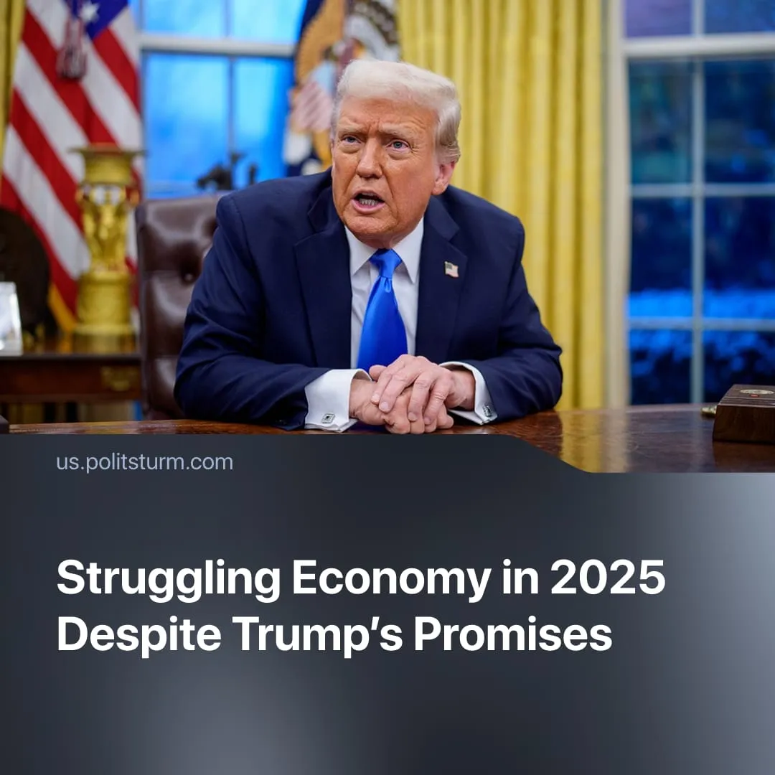

Original article
2025-12-27
2 min read

Trump promised a stronger economy at the start of 2025. Yet workers continue to face high prices and rising unemployment.
Details. Employment growth slowed in 2025 and is trending toward 0%. Trump’s deportations have removed roughly 750,000 migrants from the labour force, while expanded AI adoption, mass layoffs, and economic uncertainty continue to threaten millions with unemployment.
► Average inflation reached 3%, while prices for key goods (e.g., coffee) rose by over 10%. The Consumer Price Index peaked in September at 324.8, up from 315.61 in December 2024, indicating a significant increase in the overall cost of living. Meanwhile, 83% of hourly workers have less than $500 in savings, and minimum-wage workers ($7.25/hour) now live below the poverty line.
► The national debt rose from $36.22 trillion to $38 trillion, with the budget deficit hitting $1.4–1.8 trillion. Most spending cuts targeted social programs, while about $1 trillion was allocated to the military.
► 60% of Americans remain concerned about the current economic situation. Recently, Trump acknowledged failing to address these problems, lower prices, or secure jobs, yet blamed former President Biden for the situation.
Context. Trump’s campaign and administration centred on promises of a “Golden Age” following Biden’s predictable failures to resolve capitalism’s contradictions. Promises of tax cuts, job creation, and lower prices were paired, once in office, with selective data and rhetoric designed to mislead workers.
► Amid these promises, 52% of American voters supported Trump primarily because of the economic solutions he proposed.
► Trump promised more affordable housing and healthcare. While rents and some drug prices fell slightly, high mortgage costs and limited healthcare coverage remained.
► In November, the White House highlighted selective price declines and real wage gains measured from an inflation-depressed baseline as “big progress,” concealing the permanently higher cost of living for workers.
► In December, the administration claimed “100% private-sector job growth,” and for “native-born Americans — NOT illegals.” meaning all new jobs recorded were outside the public sector, while failing to mention that overall job growth remained weak.
► The administration presented the One Big Beautiful Bill as reducing spending and national debt for Americans’ benefit. In reality, it increased deficits, prioritised militarisation, and shifted the burden onto social spending cuts.
Important to Know. The outcomes of Trump’s rule are predictable. His economic agenda advances the interests of the American capitalist class. Tax cuts, deregulation, tariffs, militarisation, and selective interventions all protect capital and increase profits while transferring costs to working-class households.
► Trump’s program is also conditioned by global economic stagnation. The World Bank describes the current period as the slowest growth since the 1960s. Falling demand sharpens the imperialist crisis, intensifies inter-capitalist competition, and compels heightened exploitation and conflict to defend capital accumulation.
► Workers face intensified exploitation, higher living costs, and limited access to affordable housing and healthcare, whilst a bipartisan ideological offensive was launched against the broad left, with communists being targeted as a result.
► The Democrats gained popularity by promoting populist left-wing candidates, such as Mamdani, to exploit Trump’s unpopularity, promising to “fix” capitalism through moderate reforms – just as Trump promised a “Golden Age” amid Biden’s failures. By advocating reforms that leave private property and capitalist accumulation intact, these reformists advance the stability and interests of the capitalist class, not the working class.

Original article

