Strikes and Work Stoppages Increase in 2018
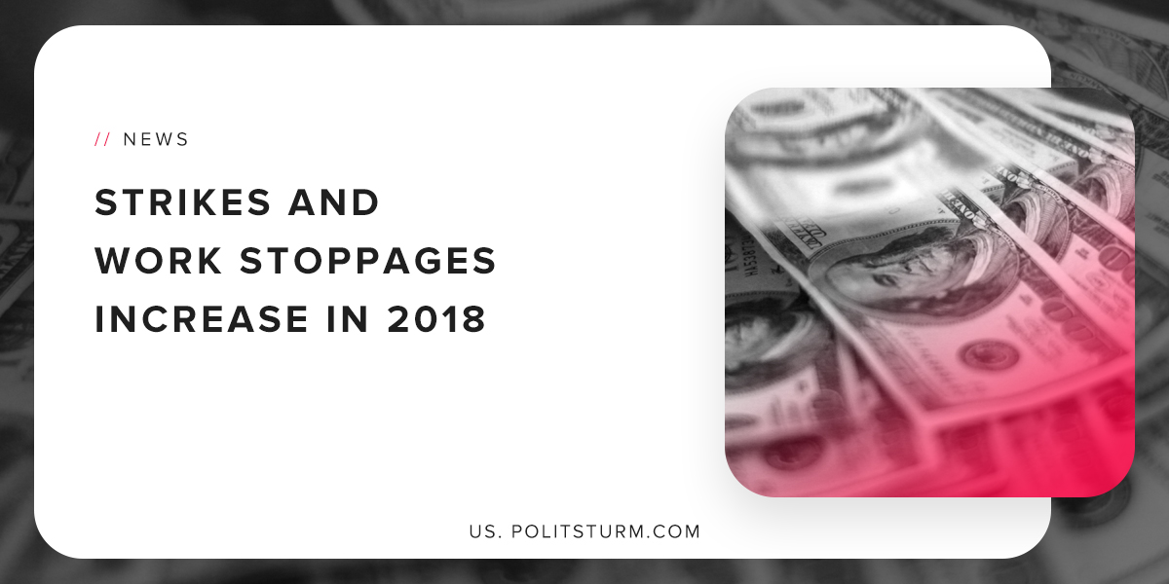

Original article
2019-03-22
1 min read

New data released by the U.S Bureau of Labor Statistics shows an increase in the number of workers affected by work stoppages. 485,200 workers were affected by work stoppages in 2018, which includes workers who are on strike or are locked out.
This figure has not been this high since 1986, when 533,000 workers were affected by strikes and lockouts. Major contributors to this trend were the teachers strikes across the country, the Marriott hotel workers strike, and the National Grid work stoppage.
The vast majority of workers who participated in strikes and work stoppages can be attributed to the educational, health care, and social assistant workers.
Work stoppages and strikes were on a prolonged decline over the past 80 years, and we are now seeing an uptick in strikes and work stoppages the late phase of the industrial cycle. Workers in the U.S have had some recent victories in winning concessions from the capitalist class in negotiating better labor contracts.
It is imperative that the workers continue to struggle against the capitalists and use strikes and work stoppages as a tool. However, the workers must recognize that the capitalist system is predicated upon the extraction of profits from the working class. The only long-term solution to the contradictions of capitalism is the institution of socialism and the dictatorship of the proletariat.

https://www.bls.gov/opub/ted/2019/20-major-work-stoppages-in-2018-involving-485000-workers.htm
https://www.bls.gov/news.release/archives/wkstp_02082019.htm
https://fred.stlouisfed.org/series/LES1252881600Q

Original article

