Steve Wynn on the Rich
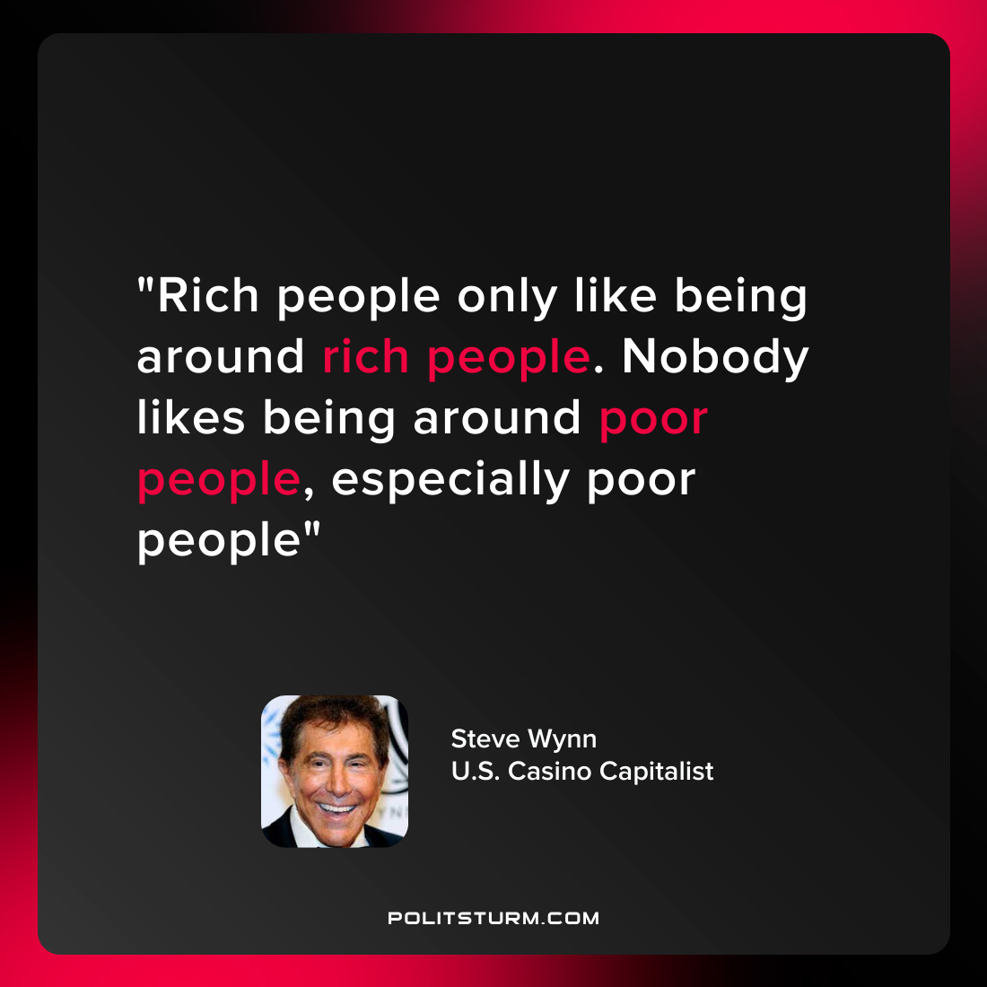

Original article
2022-04-16

“Rich people only like being around rich people. Nobody likes being around poor people, especially poor people”
~Steve Wynn
U.S. Casino Capitalist

Original article

