Staten Island Amazon Workers Vote in Favor of Unionization
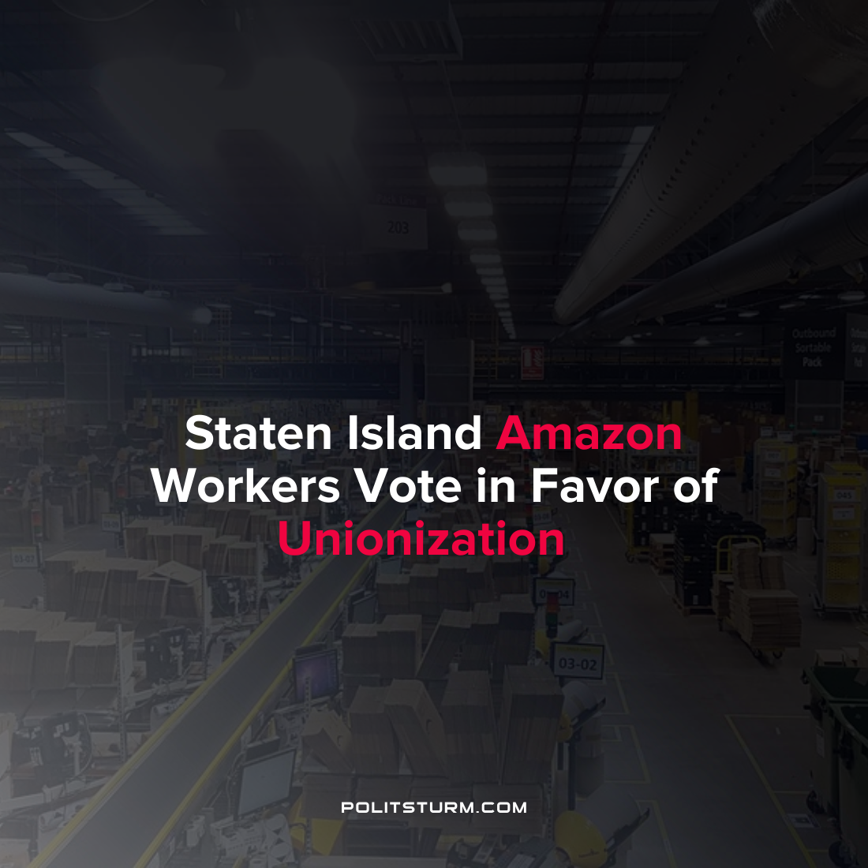

Original article
2022-04-01
1 min read

Workers at the Amazon warehouse located in Staten Island, New York (JFK8) voted in favor of joining a union. This is the first time that a U.S. Amazon facility has voted in favor of unionization. Amazon has bitterly campaigned against the unionization efforts of its employees, however, they were unsuccessful at stopping the formation of the union.
Of the 4,785 ballots that were cast in the union election conducted by the National Labor Relations Board, 2,654 were in favor of the Amazon Labor Union. The results have been published but have not been certified at this time as objections can still be filed up until April 8, 2022, however the uncertified results show a clear victory for the Amazon Labor Union.
Unionization efforts were spearheaded by the Amazon Labor Union which was led by Christian Smalls, a former employee who was fired for staging a walkout over the lack of worker COVID precautions. Amazon’s lawyer David Zapolsky referred to Smalls as “not smart, or articulate” and wished that he would become the face of the unionization movement. It appears that Smalls has become the face of the unionization efforts which have successfully unionized the first U.S Amazon location.
The victory of the Amazon Workers Union to form a union despite the struggle of the employer shows what organized workers are capable of. However, organization needs to have a Marxist-Leninist basis for it is the most powerful tool in exposing the lies of the capitalists and in ending the exploitation of man by man.
Source:1 2

Original article

