State Bill Makes Strike and Work Stoppages Unlawful
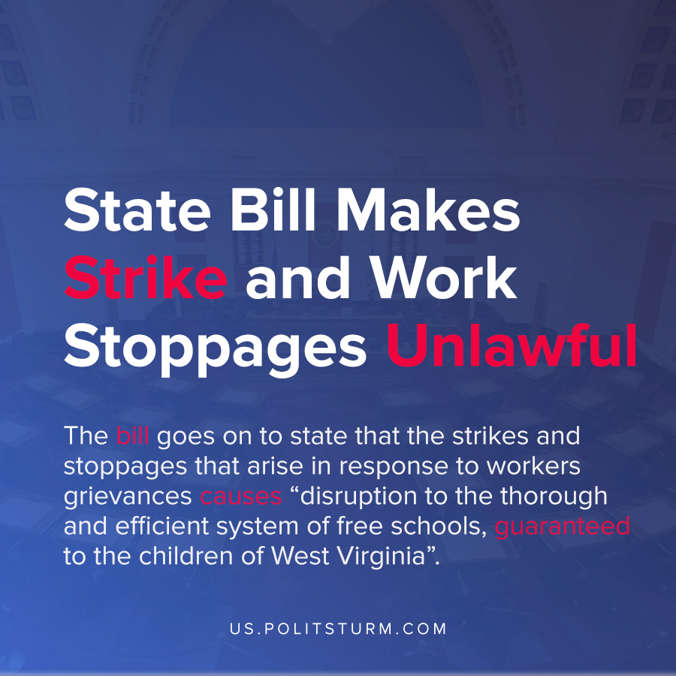

Original article
2021-02-25
1 min read

A new Senate bill from the state of West Virginia would amend the existing law to make work stoppages and strikes by public employees unlawful. In addition, workers who participated in a strike or work stoppage can be fired.
The bill comes in the aftermath of a wave of teacher strikes that swept the country, including West Virginia teacher strikes in 2018.
The rationale for the bill was that the West Virginia Supreme Court of Appeals held that “public employees have no right to strike in the absence of express legislation or, at the very least, appropriate statutory provisions for collective bargaining, mediation, and arbitration”.
Thus according to the highest court of appeals in West Virginia, public workers do not have the right to strike or express their grievances or even collective bargaining.
The bill goes on to state that the strikes and stoppages that arise in response to workers grievances causes “disruption to the thorough and efficient system of free schools, guaranteed to the children of West Virginia”. Since every strike or work stoppage would be considered a disruption the bill is targeting the workers ability to organize and strike.
Behind the rhetoric, we unsurprisingly see the legislation and courts siding in favor of the employers and against the working class. Rather than the state mediating conflict between classes, it is rather simply under the control of and run in the interests of the bourgeoisie.
The struggle between workers and their employers through this legislation in a modern example of class struggle, with the Senate bill being a reaction to the teacher strikes.
Source: 1

Original article

