Labour's Starmer Promises to be More Conservative than Conservatives
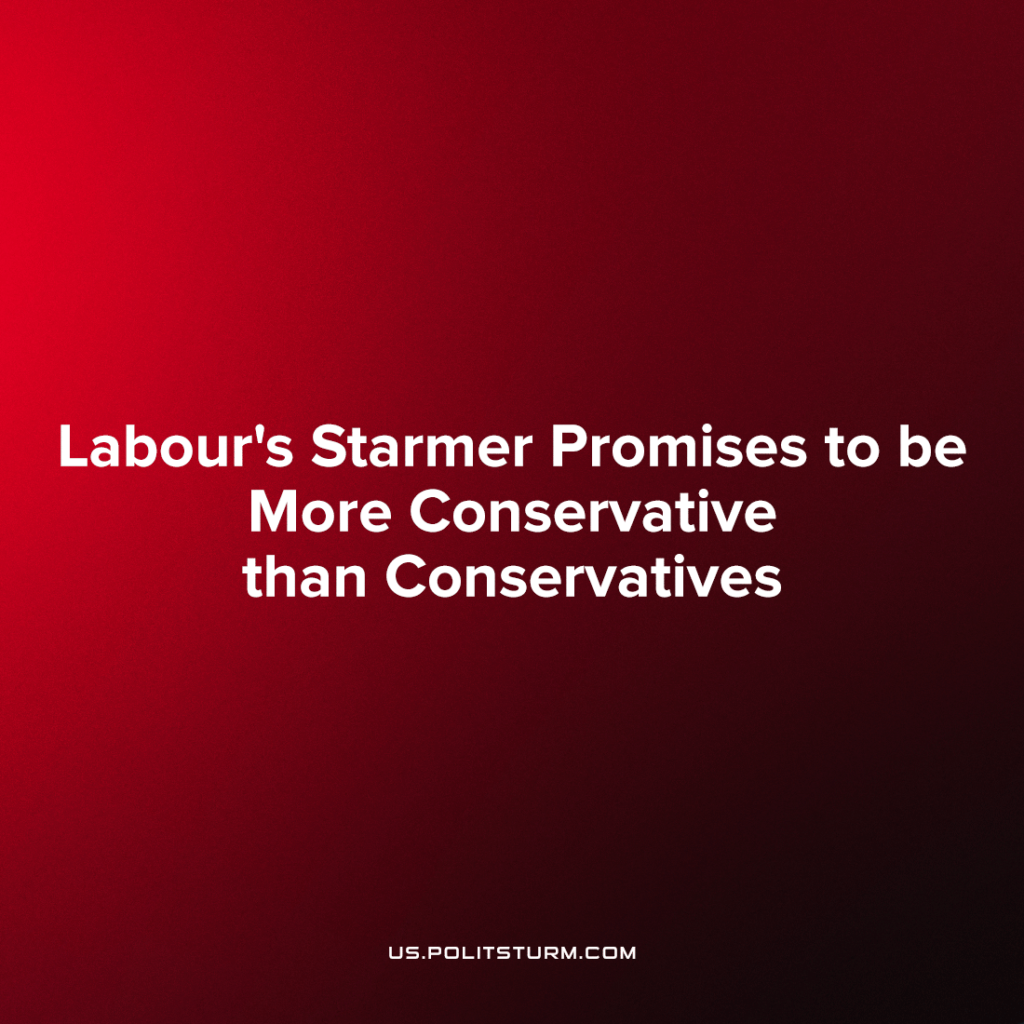

Original article
2023-05-25
2 min read

The head of the Labour Party and Leader of the Opposition in Parliament, Sir Keir Starmer, has set his sights on the office of Prime Minister and ending over a decade of Conservative Party governance. Swept into the position after an internal coup due to the failure of Jeremy Corbyn to win the premiership under his social-democratic programme, Starmer has wasted no time in clamping down on this brief return to social-democracy. He has consistently reassured his bourgeois backers that he will work tirelessly to make sure that their revenues shall go untaxed, the railways shall not be nationalised and that not even the slightest infringement of their private property shall occur.
Fittingly, Starmer has now sought to sway over sections of the bourgeoisie ahead of the coming general election that tenuously support the Conservative Party and take the premiership for himself. As Politsturm has reported on, the Tories have been mired in scandal after scandal for almost four years and now are struggling to stay afloat as their decade-long governance is now showing its age. Starmer’s latest press appearances have sought to demonstrate him as a capable politician that can govern better than the Conservatives, presenting himself as “more Tory than the Tories.”
In a recent speech given on the 12th of May 2023, the Labour leader stated that he wished to go ‘further and deeper than New Labour’s rewriting of Clause Four,’ adding that his policies wish to emulate Tony Blair’s notorious removal of Clause Four but ‘on steroids.’ This open admission that not only Labour’s social-democratic aspects are dead but that he wants to go further than Tony Blair in orienting the party politically towards modern “neoliberal” policies demonstrate precisely that no bourgeois political group, no matter how left-wing they may try to depict themselves, will ever seek to abolish capitalism and build a socialist economy.
Starmer himself made it clear to Labour voters who feel incensed at this perceived betrayal of Labour’s social-democratic heritage with the following:
‘And look – if that sounds conservative, then let me tell you: I don’t care.’
The thoroughly bourgeois nature of Labour is becoming more and more apparent with every passing day. On the 16th of May 2023, Labour failed to vote to repeal the Public Order Act which strengthens authoritarian crackdowns on protests with the Labour MP stating the reasoning as ‘some protests go too far.’ Thus we can see a clear demonstration that Labour’s leftwing appearance is but a thin veneer covering its bourgeois nature. The Labour Party refused to demonstrate its opposition to the law because it stands to gain from its implementation should Starmer become Prime Minister; should popular anger arise from Labour’s reactionary policies and stances, it is useful to have legal justification for the repression of the working-class. Labour’s actions demonstrate the correctness of the Marxist-Leninist analysis that social-democratic parties are objectively the moderate wing of fascism.
Labour’s free-market stance is reflected in a recent Times interview with Starmer where he says that in order to solve the housing crisis in Britain, he would allow the construction of housing in the Green Belt surrounding London. This solution, no different a suggestion than from the real-estate lobbyists, would dissolve the state protections for the environment and air quality of London and surrounding cities. But that look only skirts the surface; Labour’s policy is designed specifically to benefit large landowners and landlords, the division of land will be done in such a manner that ordinary Britons will not benefit but those that can afford to buy up large swathes, clear it and develop it will profit enormously. Starmer claims ‘Labour will rebuild the working-class dream of owning a home’ but this is only a plank in the capitalist's platform of illusion.
Sources: 1

Original article

