Starmer Defends Closer Ties with the EU
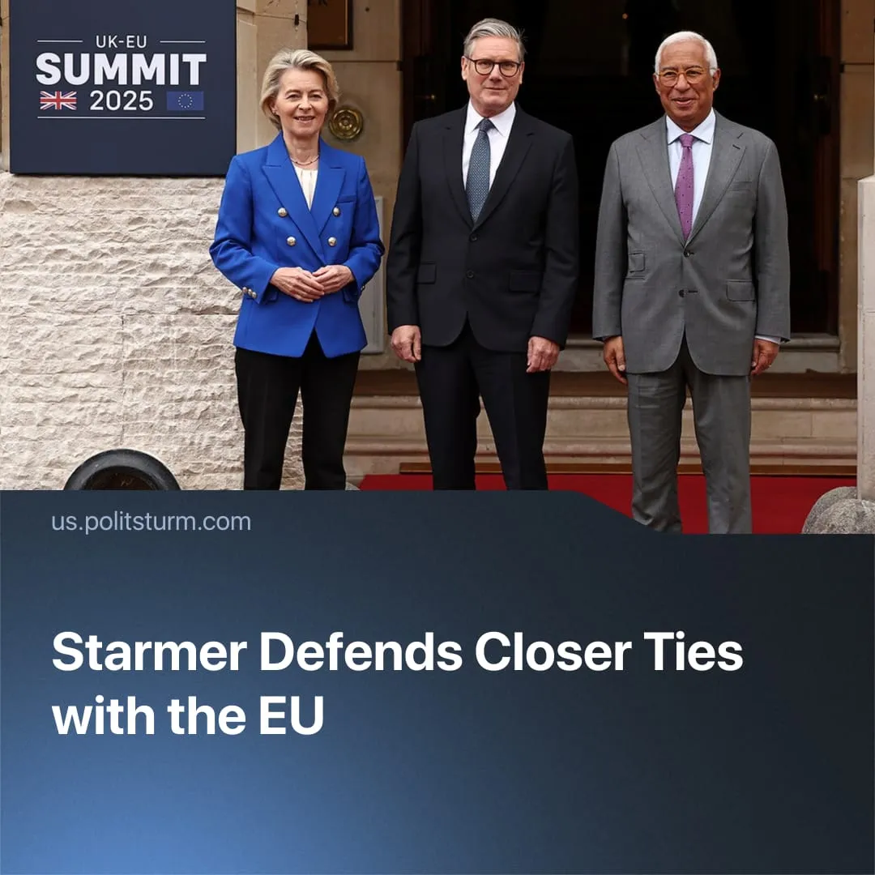

Original article
2026-01-14
1 min read

Starmer pushed towards closer ties to the EU bloc as tensions with the US continue to rise.
Details. Starmer has recently defended closer ties to the EU bloc, going as far as stating that the UK should seek access to the single market rather than limit itself to a customs union. He presents this shift as being in the national interest, placing it alongside previous trade agreements with the US and India.
► Nigel Farage, leader of Reform UK, accused Starmer of betraying the 2016 Brexit mandate – Britain's departure from the EU – pledging to fight what he calls government “Brexit backsliding” that could raise taxpayer contributions to the EU.
► The Conservatives share this stance, with Priti Patel claiming that Starmer’s push for closer EU single-market alignment is a “Brexit betrayal” that undermines the UK’s freedom to set regulations and negotiate independent trade deals.
► Labour frames the policy as a pragmatic fix to post-Brexit disruptions, while insisting Brexit itself remains intact. The Liberal Democrats welcomed the closer EU alignment.
Context. After Brexit failed to make the UK a more independent imperialist power, it has shifted to balancing its semi-dependent position between US and EU imperialist interests.
► The EU provides closer access to markets and a broader trade framework than UK–US agreements, with established mechanisms for economic coordination. Recently, France and the UK also agreed to deploy troops to Ukraine under a proposed peace plan, reaffirming commitments from existing defence arrangements.
► American imperialism, with Trump as its figurehead, has become increasingly unpredictable. Recently, he announced US withdrawal from international institutions, revived threats of annexing Greenland – prompting warnings from Denmark about risks to NATO’s stability – and has publicly contradicted EU positions on the “SMO”.
► Mark Rutte reiterated that NATO “cannot exist without the US,” leveraging this to benefit American capitalism. In 2025, such US unpredictability drove the EU to push for greater strategic autonomy, leaving the UK to pick its alignment.
► British public opinion leans toward Europe over Washington: around half would support rejoining the EU, a clear majority view Brexit as a mistake, and only 22 % view Trump favourably versus 72 % unfavourably.

Original article

