Starbucks Workers to Vote On Unionization
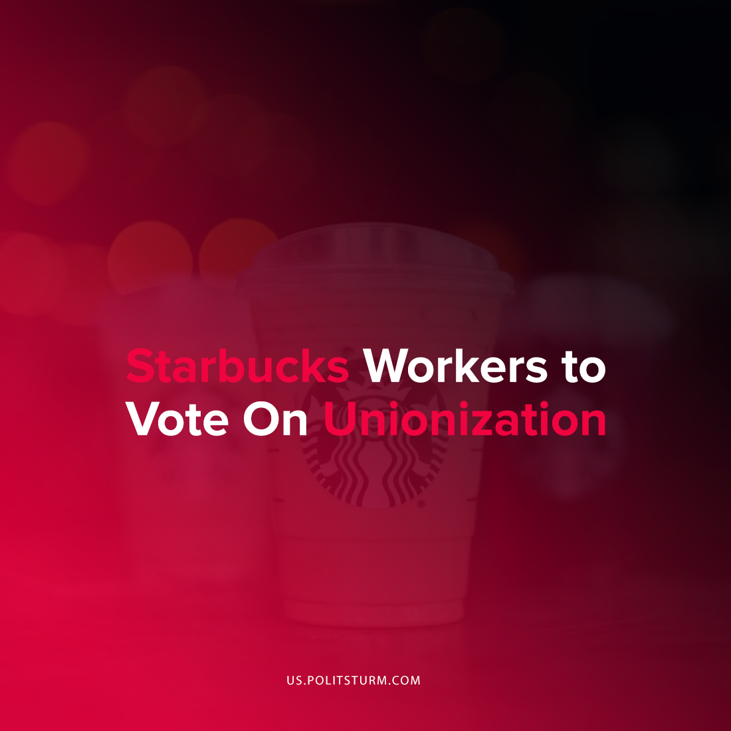

Original article
2021-10-29
1 min read

Starbucks workers in Buffalo will be holding elections to unionize 3 Starbucks locations following a National Labor Relations Board ruling. If the union vote is successful they would be the first Starbucks locations in the U.S. to have a union. The formation of a union was spearheaded by Starbucks Workers United who noted that the company “all too often puts large shareholders above all else”.
“Our storied success has come from our working directly together as partners, without a third party between us”, the company said in a statement following the ruling. Starbucks has come out in opposition to any union organization.
Three separate elections will take place with mail-in ballots due on December 8th, with the vote count on December 9th.
The ability to form a union at one of the largest corporations in the United States is definitely noteworthy and a representation of the struggle between the capitalists and workers. However, the formation of a union alone will not stop the exploitation of the workers. In addition to union organization it is necessary that workers understand and apply Marxist-Leninist theory to end capitalist wage slavery and exploitation once and for all. As long as private ownership over the means of production continues to exist, capitalists will continue to appropriate profits and fight tooth and nail against the workers.
Sources: 1 , 2

Original article

