Starbucks Union Claims Ithaca Store Closure In Retaliation of Union Activism
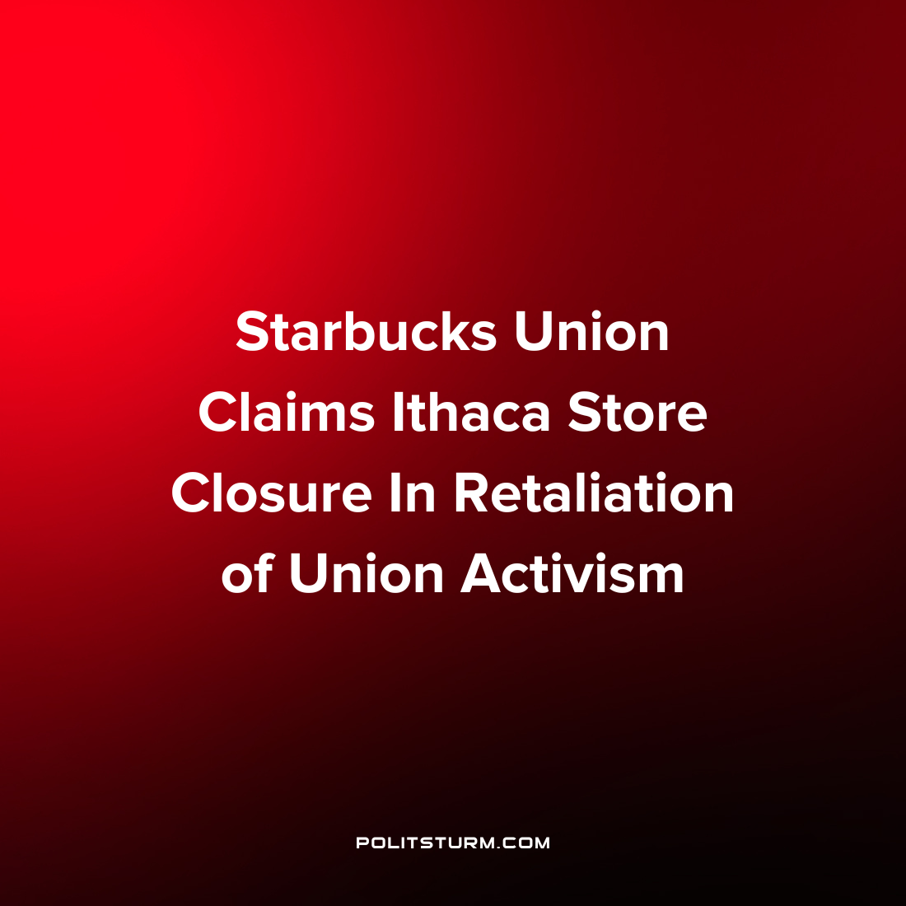

Original article
2022-06-04
1 min read

A report by Bloomberg alleges that Starbucks decided to close one of their Ithaca, New York locations in retaliation to recent union activism. The workers union filed a complaint with the National Labor Relations Board on Friday stating that the closure of the store constituted an illegal act.
Employees at the particular location had voted to unionize in April amidst reports of unsafe working conditions in the location. Specifically, an overflowing grease trap in the store was spilling wastewater and oil onto the floor making working conditions unsafe for the workers.
Starbucks Attorney Alan Model e-mailed the union about the news of the store closure and the stated rationale behind the decision.
“As you know, there have been many issues with regard to the condition of the store (e.g., the grease trap) and it does not make sense to further operate the store”, said Model regarding the decision.
As the number of unionization petitions and election victories has increased dramatically over the last several months, the struggle between the capitalist class and the workers has become more visibly apparent in the case of Starbucks. The union regional leader Gary Bonadonna described the closure as “an act of war” and has stated that the union supports the workers in their struggle for better working conditions. Despite the union not organizing upon Marxist-Leninist principles, the company clearly views any worker organization as a potential threat to profitability and has taken heavy-handed action to defend the class interests of the capitalist class.
Source: 1 2

Original article

