Starbucks Illegally Fires Employee for Union Activity
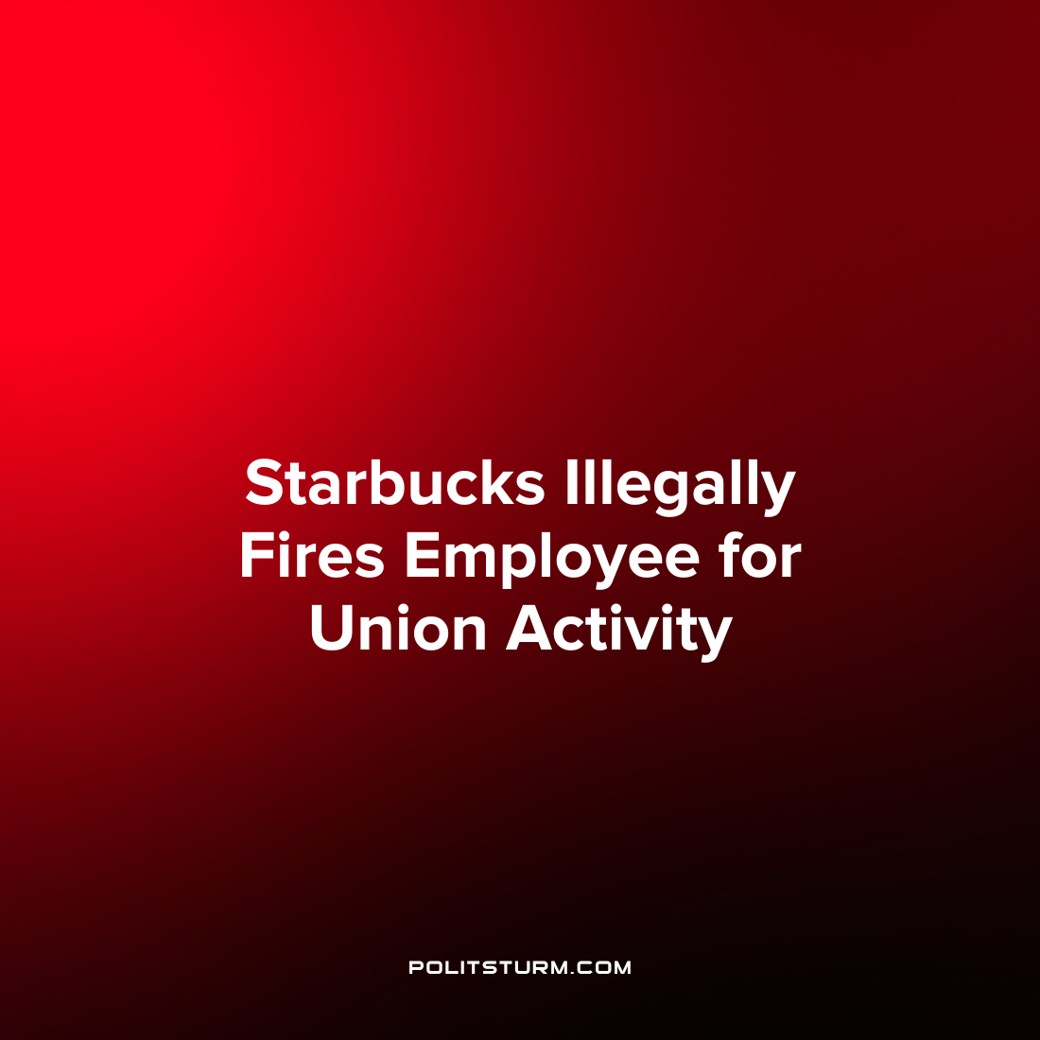

Original article
2022-10-07
1 min read

The National Labor Relations Board (NLRB) ruled that Starbucks illegally fired an employee who was engaged in union activism. While Starbucks has alleged that claims of anti-union activity are categorically false, a judge issued a cease and desist letter to the corporation ordering that they stop firing employees who engage in union activity.
While Starbucks defended that the firing of the employee in question, Hannah Whitbeck, was on fair grounds their defense was dubious. The judge found it “suspicious” that they discharged the employee in the midst of a unionization campaign and that no other employees had been fired in the state of Michigan for the same alleged infractions of Whitbeck. Also of note, the ruling observed that Starbucks “acted with animus” when it fired Whitbeck and that one of the individuals responsible for the firing held strong anti-union sentiment. This individual, Starbucks District Manager Paige Schmehl, allegedly monitored employees at the Starbucks Union “sip-ins” for a period of 3 hours which arguably created the impression of surveillance and was deemed “unusual”.
As a result of the order, Whitbeck will be re-hired and will be issued backpay. However, this instance reveals that despite the rhetoric of the employers, the class struggle is a continuous process under capitalism and that the shareholders and executives will protect their class interests using any methods available to them, even if they are not legal within the framework of the capitalist legal system which already serves their interests. It is necessary for workers to organize under Marxist-Leninist principles to defend the class interests of the working class and end capitalist wage slavery.
Source: 1

Original article

