Stalin's Birthday: 144th Anniversary
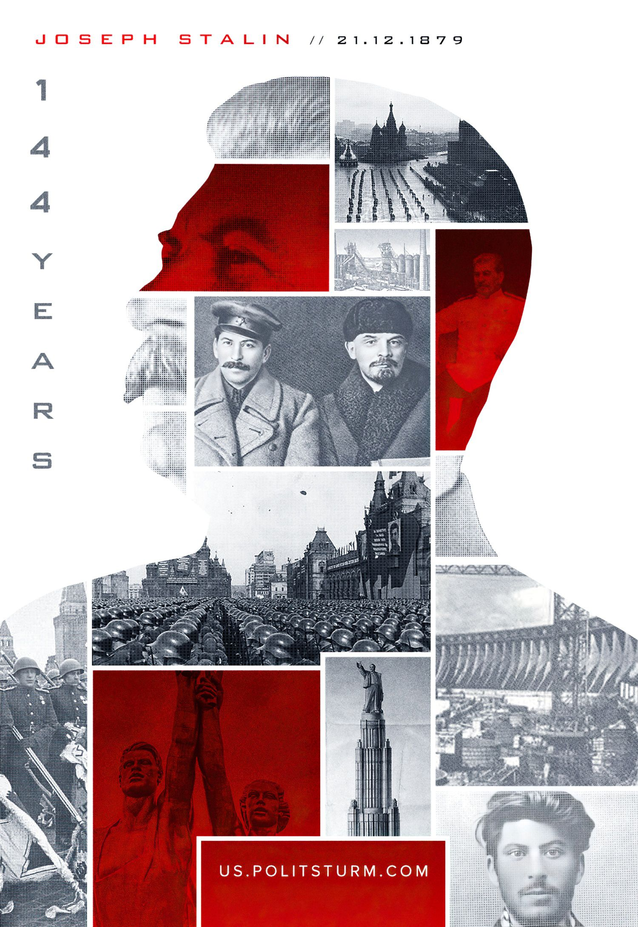

Original article
2023-12-21

"You can have no doubt, comrades, that I am ready to continue to devote all my strength, all my abilities and, if necessary, all my blood, drop by drop, to the cause of the working class, to the cause of the proletarian revolution and world communism" – Joseph Stalin in response to greetings on his birthday at the end of 1929.

Original article

