Stalin on War as a Capitalist Response to Crisis
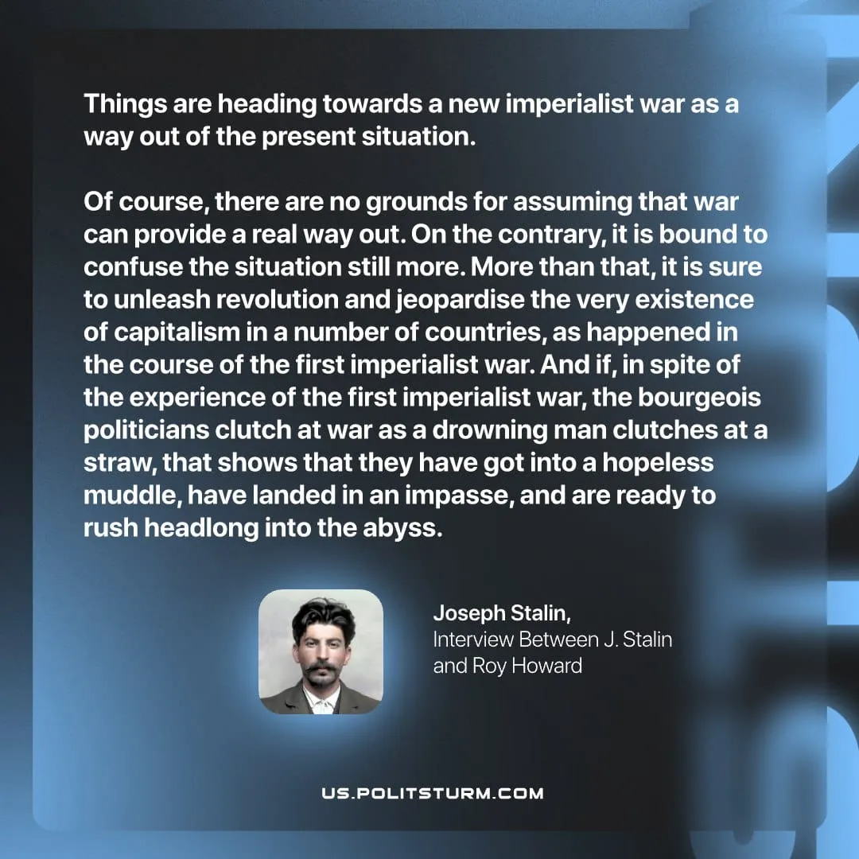

Original article
2026-04-30
1 min read

Things are heading towards a new imperialist war as a way out of the present situation.
Of course, there are no grounds for assuming that war can provide a real way out. On the contrary, it is bound to confuse the situation still more. More than that, it is sure to unleash revolution and jeopardise the very existence of capitalism in a number of countries, as happened in the course of the first imperialist war. And if, in spite of the experience of the first imperialist war, the bourgeois politicians clutch at war as a drowning man clutches at a straw, that shows that they have got into a hopeless muddle, have landed in an impasse, and are ready to rush headlong into the abyss.
Joseph Stalin, Interview Between J. Stalin and Roy Howard

Original article

