Stalin on Utopians
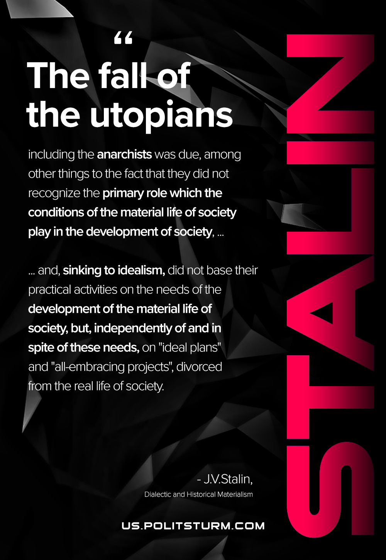

Original article
2021-01-05
1 min read

The fall of the utopians, including the Narodniks, anarchists and Socialist-Revolutionaries, was due, among other things to the fact that they did not recognize the primary role which the conditions of the material life of society play in the development of society, and, sinking to idealism, did not base their practical activities on the needs of the development of the material life of society, but, independently of and in spite of these needs, on “ideal plans” and “all-embracing projects”, divorced from the real life of society.
J. V. Stalin September 1938
Dialectical and Historical Materialism

Original article

