Stalin on Unions
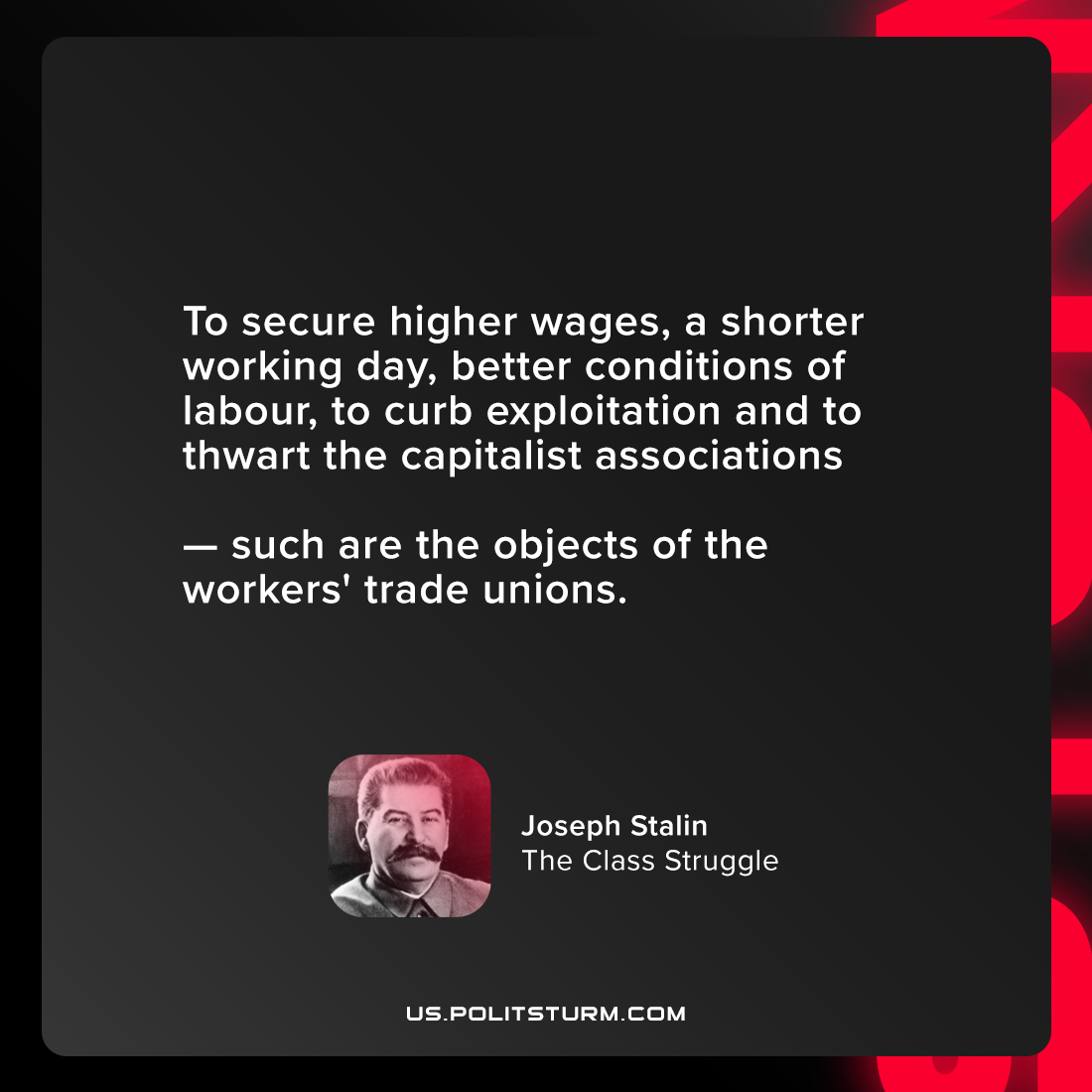

Original article
2021-08-15

To secure higher wages, a shorter working day, better conditions of labour, to curb exploitation and to thwart the capitalist associations — such are the objects of the workers’ trade unions.

Joseph Stalin, “The Class Struggle”

Original article

