Stalin on Unemployment
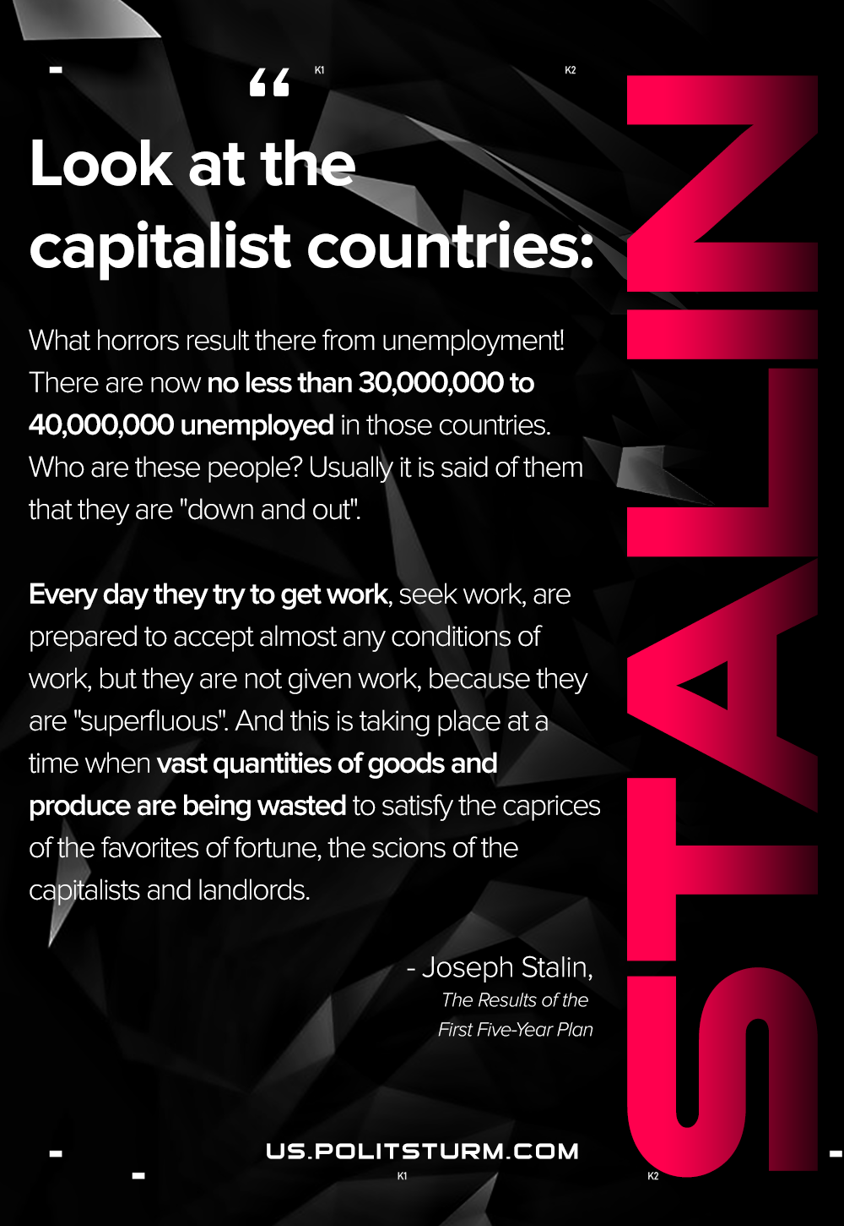

Original article
2021-02-23
1 min read

Look at the capitalist countries: what horrors result there from unemployment! There are now no less than 30,000,000 to 40,000,000 unemployed in those countries. Who are these people? Usually it is said of them that they are “down and out.”
Every day they try to get work, seek work, are prepared to accept almost any conditions of work, but they are not given work, because they are “superfluous.” And this is taking place at a time when vast quantities of goods and produce are being wasted to satisfy the caprices of the favourites of fortune, the scions of the capitalists and landlords.
Stalin, The Results of the First Five-Year Plan

Original article

