Stalin on the Withering Away of the State
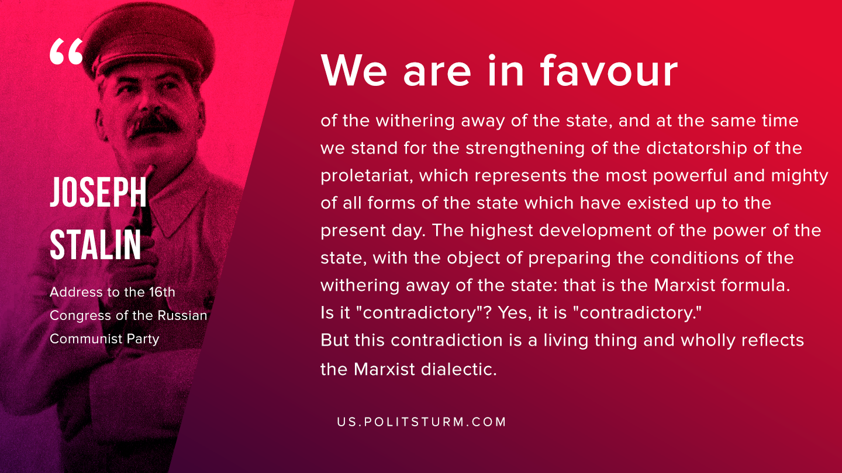

Original article
2019-09-21
1 min read

“We are in favour of the withering away of the state, and at the same time we stand for the strengthening of the dictatorship of the proletariat, which represents the most powerful and mighty of all forms of the state which have existed up to the present day. The highest development of the power of the state, with the object of preparing the conditions of the withering away of the state: that is the Marxist formula. Is it “contradictory”? Yes, it is “contradictory.” But this contradiction is a living thing and wholly reflects the Marxist dialectic.”

Original article

