Stalin on the Weakness of Imperialism
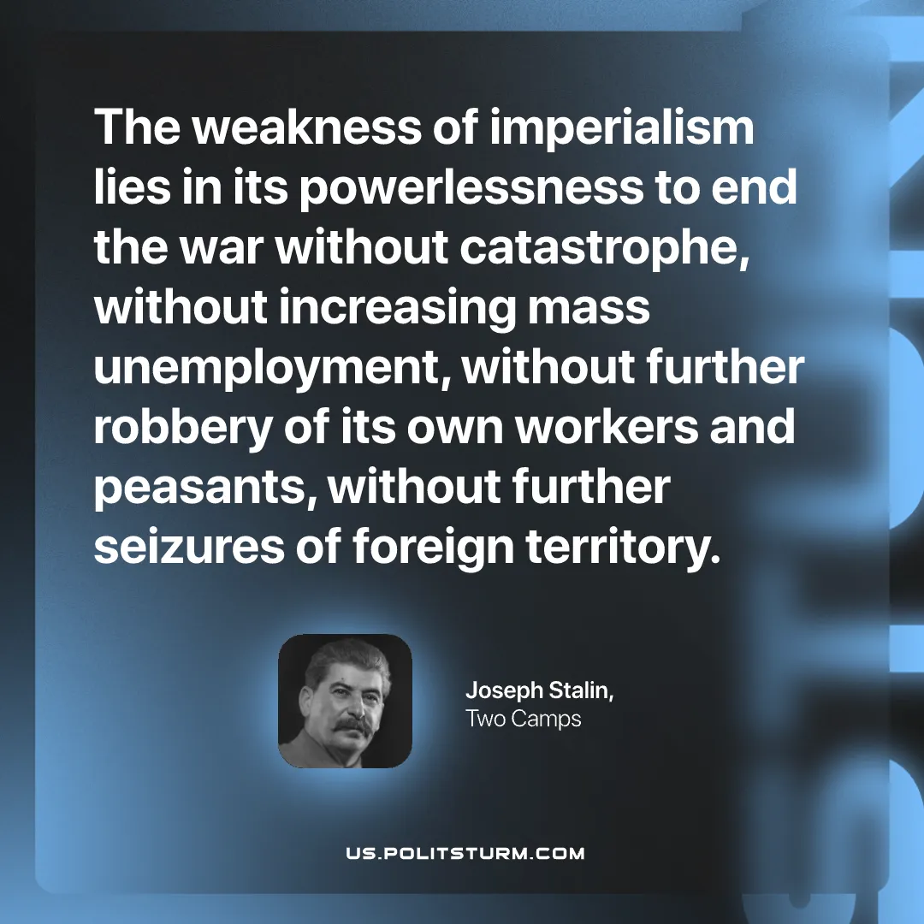

Original article
2026-08-16

The weakness of imperialism lies in its powerlessness to end the war without catastrophe, without increasing mass unemployment, without further robbery of its own workers and peasants, without further seizures of foreign territory.
Joseph Stalin, Two Camps

Original article

