Stalin on the Victory of Socialism
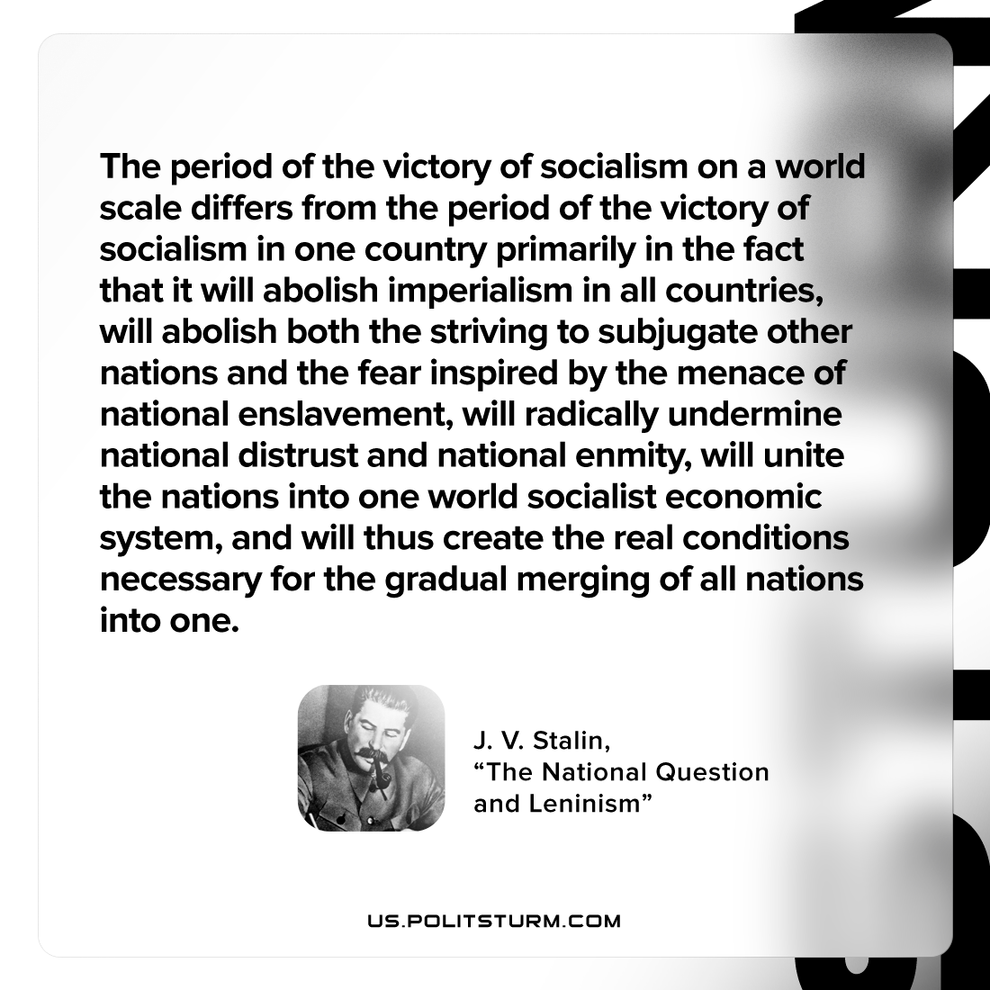

Original article
2023-03-05
1 min read

"The period of the victory of socialism on a world scale differs from the period of the victory of socialism in one country primarily in the fact that it will abolish imperialism in all countries, will abolish both the striving to subjugate other nations and the fear inspired by the menace of national enslavement, will radically undermine national distrust and national enmity, will unite the nations into one world socialist economic system, and will thus create the real conditions necessary for the gradual merging of all nations into one."
Joseph Stalin, "Marxism and the National Question"

Original article

