Stalin on the Union of the Proletariat
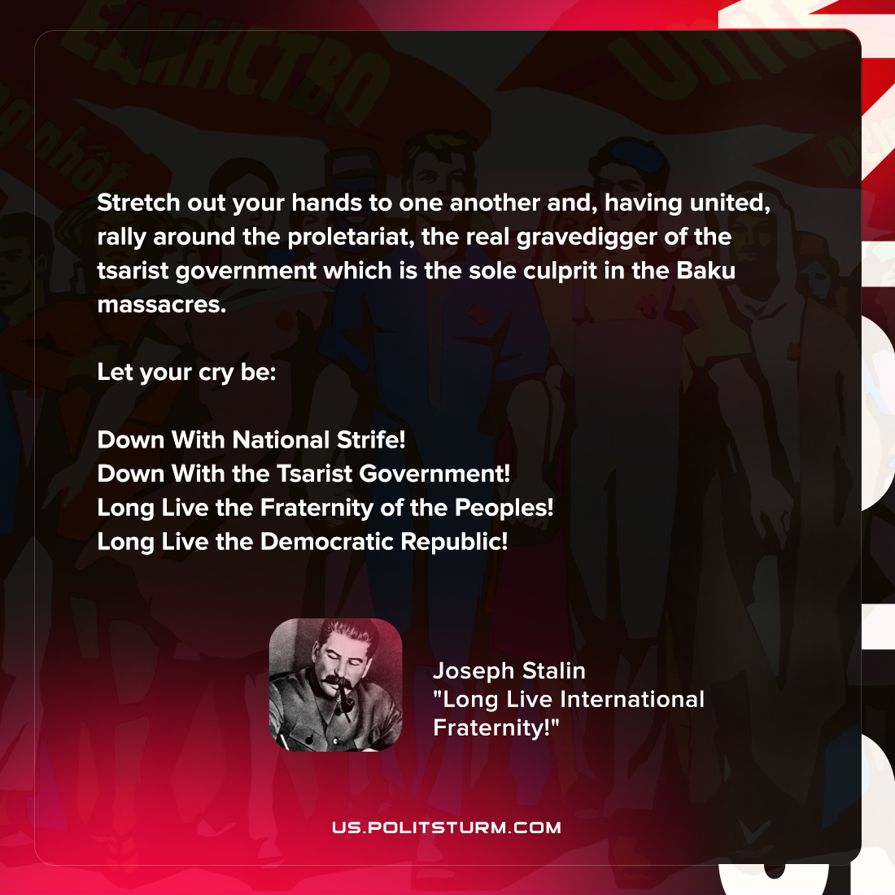

Original article
2022-04-14

Stretch out your hands to one another and, having united, rally around the proletariat, the real gravedigger of the tsarist government which is the sole culprit in the Baku massacres.
Let your cry be:
Down With National Strife!
Down With the Tsarist Government!
Long Live the Fraternity of the Peoples!
Long Live the Democratic Republic!

Joseph Stalin, “Long Live International Fraternity !”

Original article

