Stalin on the Struggle to Exist
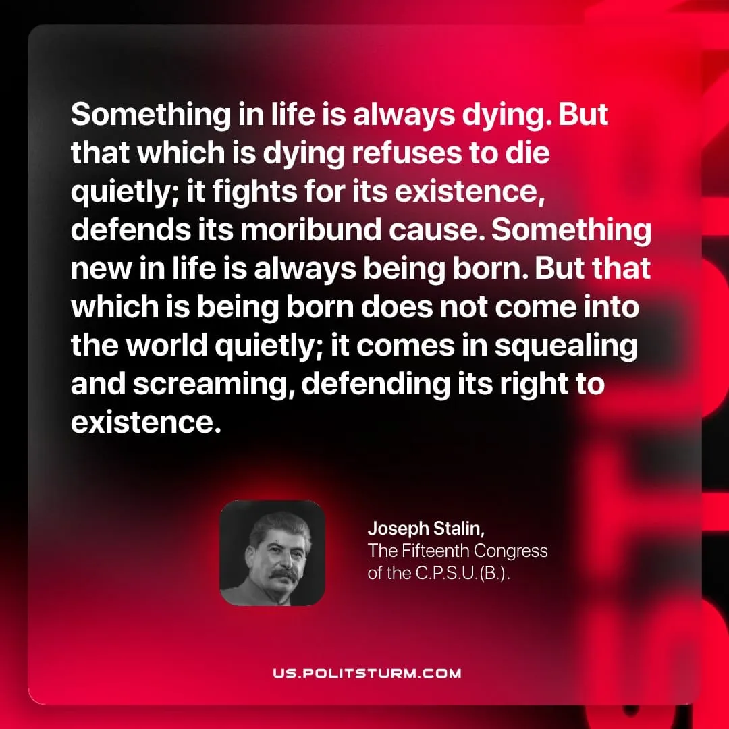

Original article
2026-05-17

Something in life is always dying. But that which is dying refuses to die quietly; it fights for its existence, defends its moribund cause. Something new in life is always being born. But that which is being born does not come into the world quietly; it comes in squealing and screaming, defending its right to existence.
Joseph Stalin, The Fifteenth Congress of the C.P.S.U.(B.)

Original article

