Stalin on the Struggle Against the Rightists
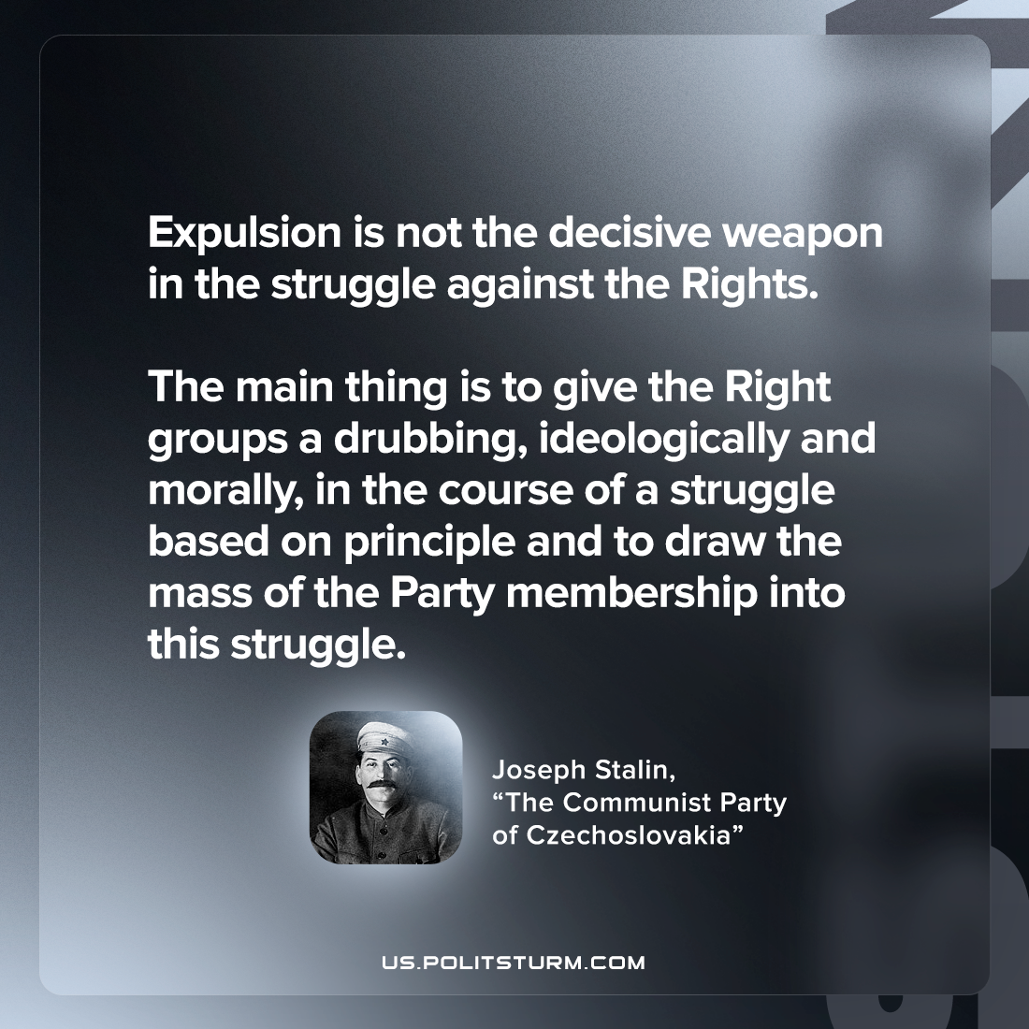

Original article
2023-02-14

"Expulsion is not the decisive weapon in the struggle against the Rights. The main thing is to give the Right groups a drubbing, ideologically and morally, in the course of a struggle based on principle and to draw the mass of the Party membership into this struggle."
Joseph Stalin, “The Communist Party of Czechoslovakia”

Original article

