Stalin on the Strength of the National Movement
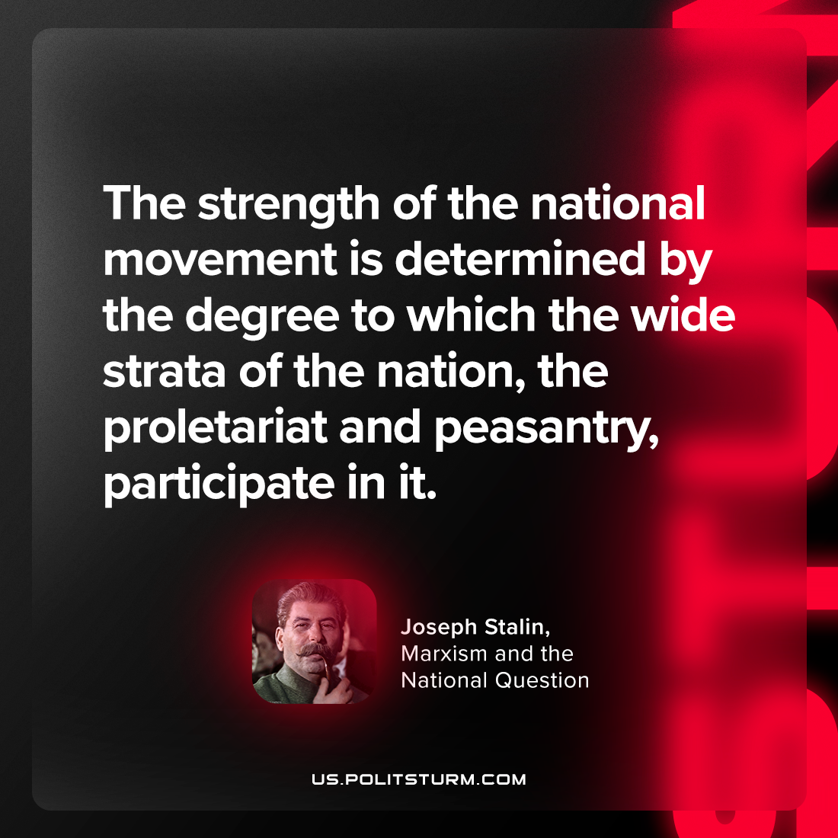

Original article
2023-10-05

"The strength of the national movement is determined by the degree to which the wide strata of the nation, the proletariat and peasantry, participate in it."
Joseph Stalin, "Marxism and the National Question"

Original article

