Stalin on the Science of Marxism
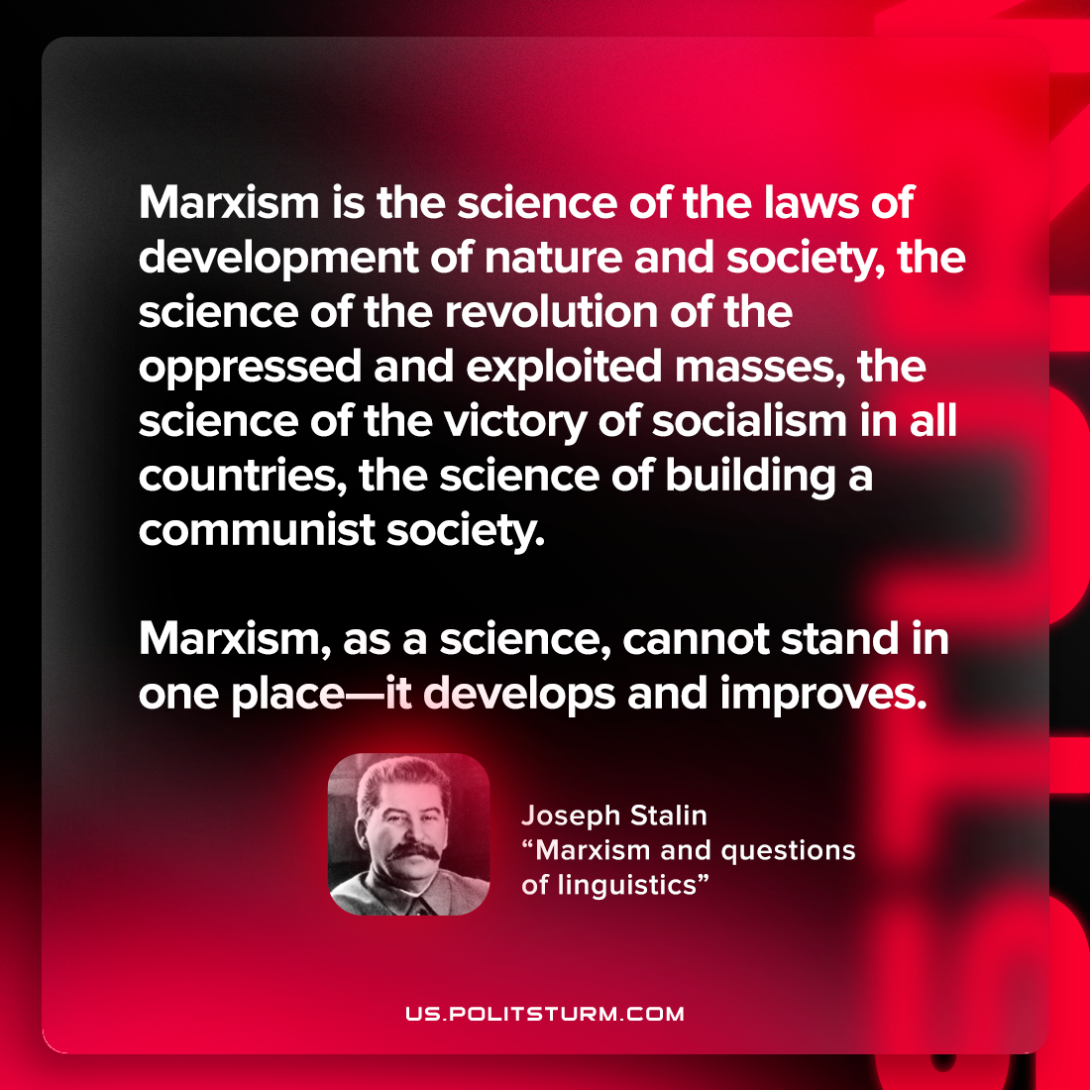

Original article
2022-09-25

Marxism is the science of the laws of development of nature and society, the science of the revolution of the oppressed and exploited masses, the science of the victory of socialism in all countries, the science of building a communist society. Marxism, as a science, cannot stand in one place—it develops and improves.
Joseph Stalin, “Marxism and questions of linguistics”

Original article

