Stalin on the Right of Nations to Self-Determination
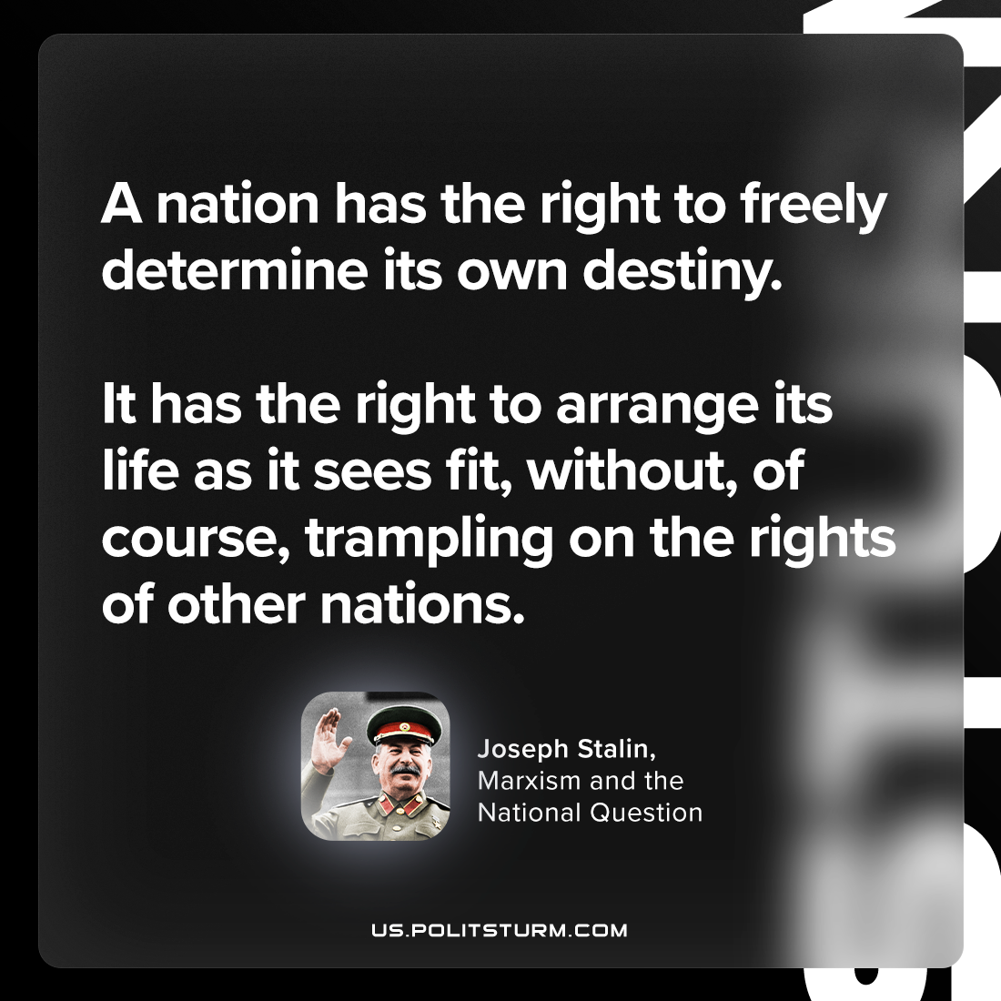

Original article
2023-12-24

"A nation has the right freely to determine its own destiny. It has the right to arrange its life as it sees fit, without, of course, trampling on the rights of other nations."
Joseph Stalin, Marxism and the National Question

Original article

