Stalin on The Revolution
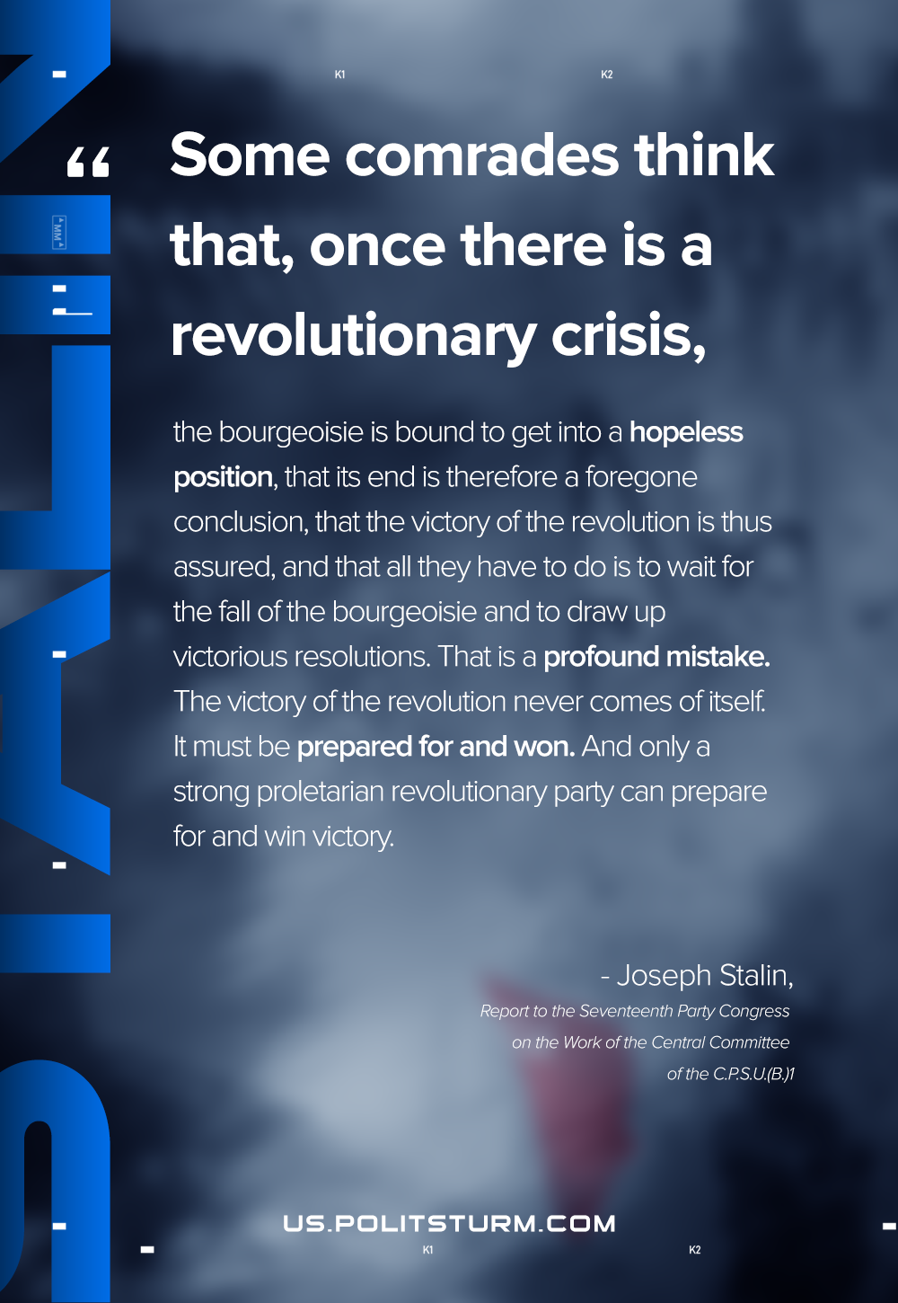

Original article
2020-12-29
1 min read

Some comrades think that, once there is a revolutionary crisis, the bourgeoisie is bound to get into a hopeless position, that its end is therefore a foregone conclusion, that the victory of the revolution is thus assured, and that all they have to do is to wait for the fall of the bourgeoisie and to draw up victorious resolutions.
That is a profound mistake. The victory of the revolution never comes of itself. It must be prepared for and won. And only a strong proletarian revolutionary party can prepare for and win victory.
Joseph Stalin, Report to the Seventeenth Party Congress on the Work of the Central Committee of the C.P.S.U.(B.)

Original article

