Stalin on the Redivision of the World
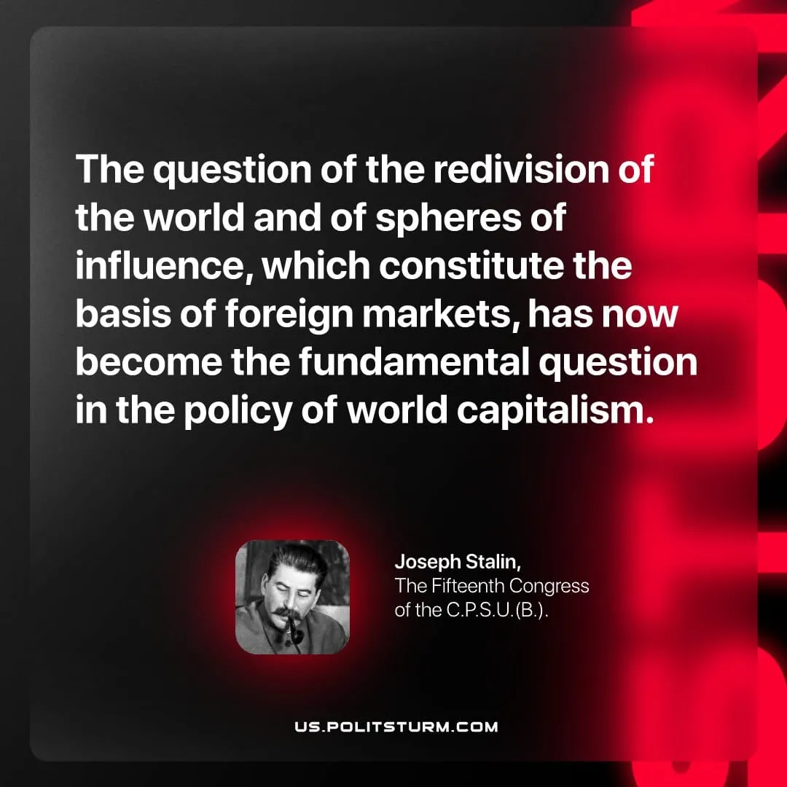

Original article
2026-05-07

The question of the redivision of the world and of spheres of influence, which constitute the basis of foreign markets, has now become the fundamental question in the policy of world capitalism.
Joseph Stalin, The Fifteenth Congress of the C.P.S.U.(B.)

Original article

