Stalin on the Realities of the Revolution
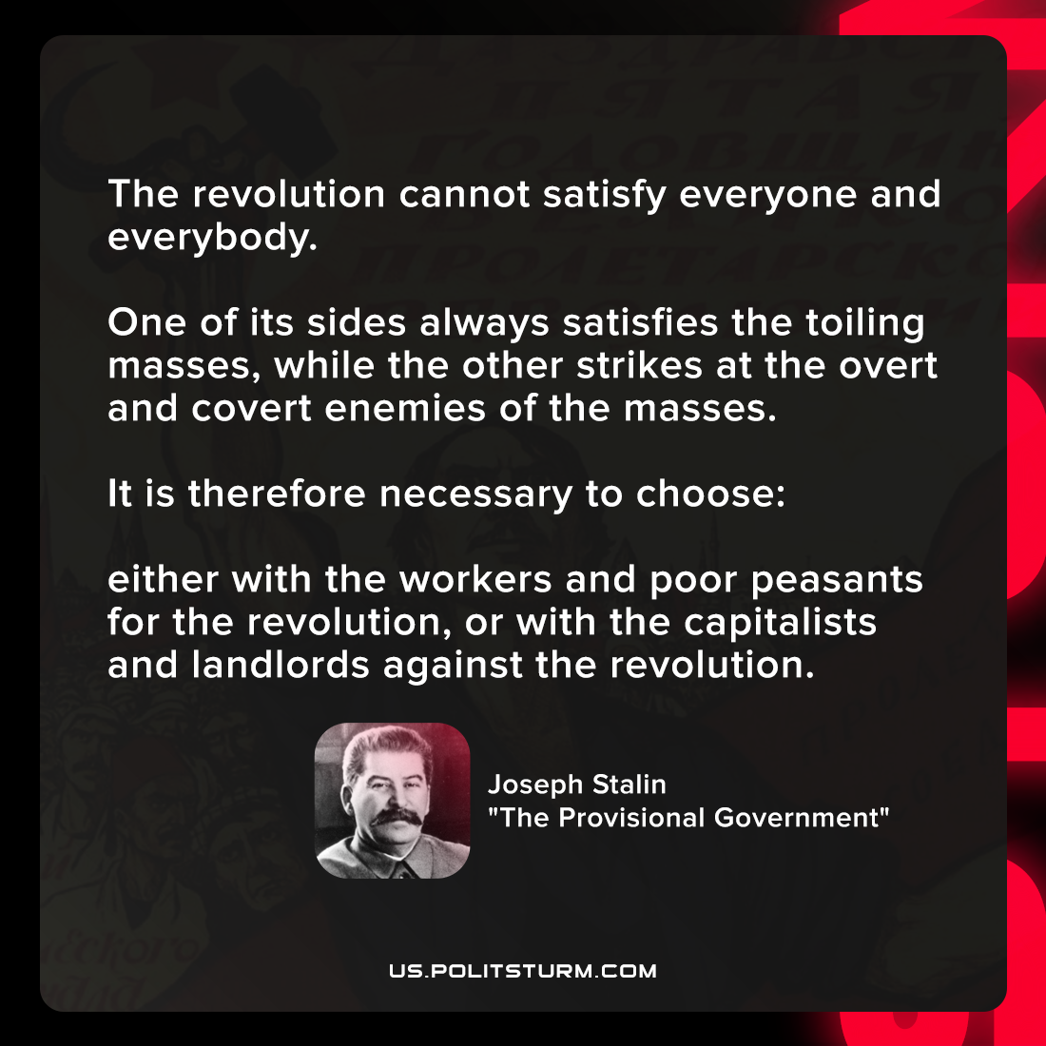

Original article
2021-12-12

The revolution cannot satisfy everyone and everybody. One of its sides always satisfies the toiling masses, while the other strikes at the overt and covert enemies of the masses.
It is therefore necessary to choose: either with the workers and poor peasants for the revolution, or with the capitalists and landlords against the revolution.

Joseph Stalin, “The Provisional Government”

Original article

