Stalin on the Primary Cause of War
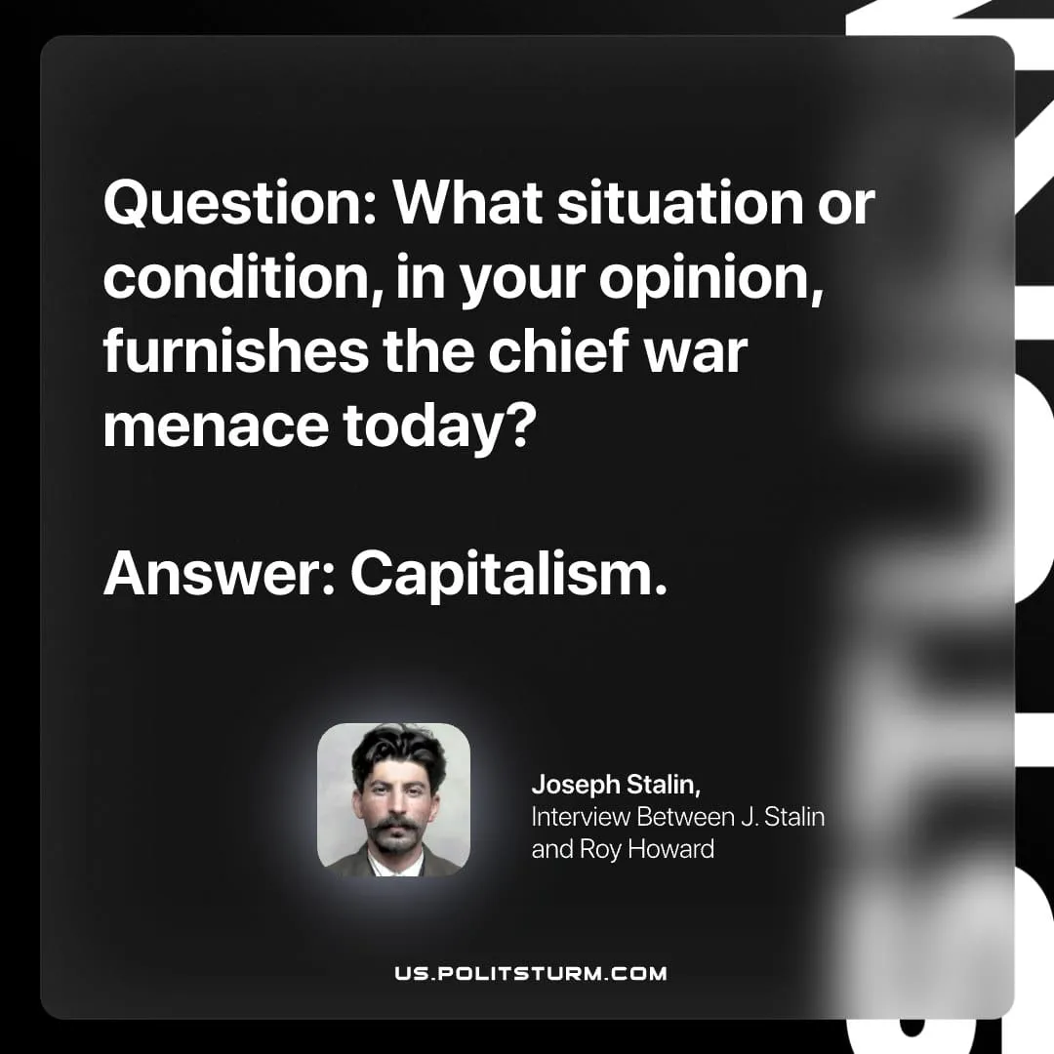

Original article
2026-04-26

Question: What situation or condition, in your opinion, furnishes the chief war menace today?
Answer: Capitalism.
Joseph Stalin, Interview Between J. Stalin and Roy Howard

Original article

