Stalin on the Power of Theory in the Movement
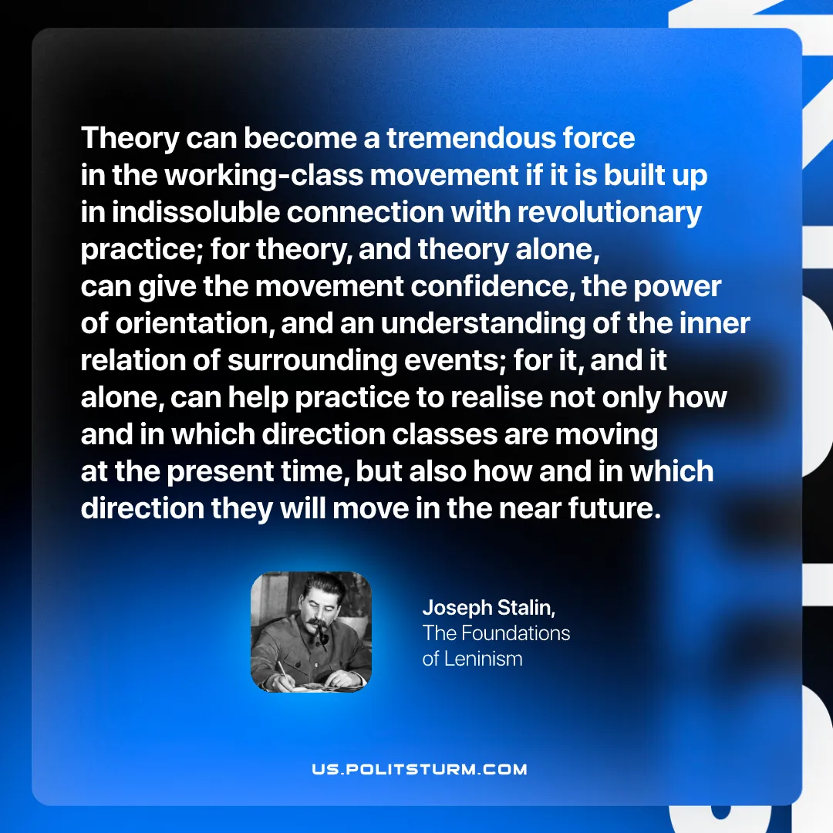

Original article
2026-01-06
1 min read

Theory can become a tremendous force in the working-class movement if it is built up in indissoluble connection with revolutionary practice; for theory, and theory alone, can give the movement confidence, the power of orientation, and an understanding of the inner relation of surrounding events; for it, and it alone, can help practice to realise not only how and
in which direction classes are moving at the present time, but also how and in which direction they will move in the near future.
Joseph Stalin, “The Foundations Of Leninism”

Original article

