Stalin on the Policy of Opportunism
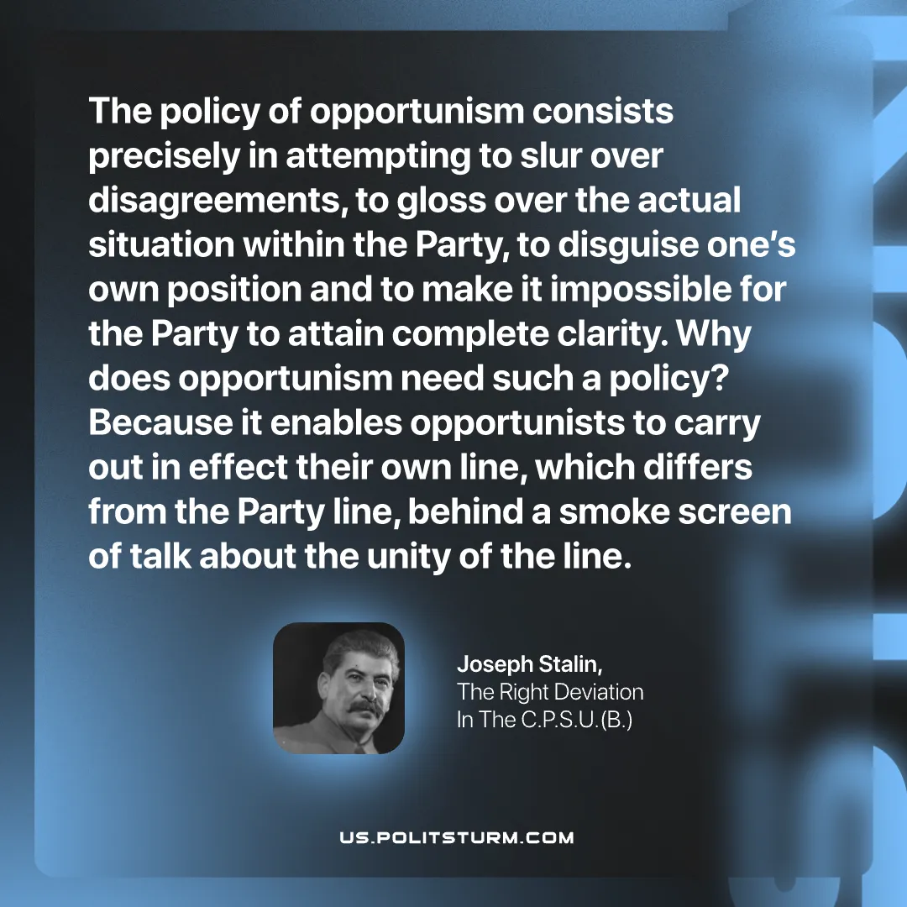

Original article
2026-01-13
1 min read

The policy of opportunism consists precisely in attempting to slur over disagreements, to gloss over the actual situation within the Party, to disguise one’s own position and to make it impossible for the Party to attain complete clarity. Why does opportunism need such a policy? Because it enables opportunists to carry out in effect their own line, which differs from the Party line, behind a smoke screen of talk about the unity of the line.
Joseph Stalin, “The Right Deviation In The C.P.S.U.(B.)”

Original article

