Stalin on the Party
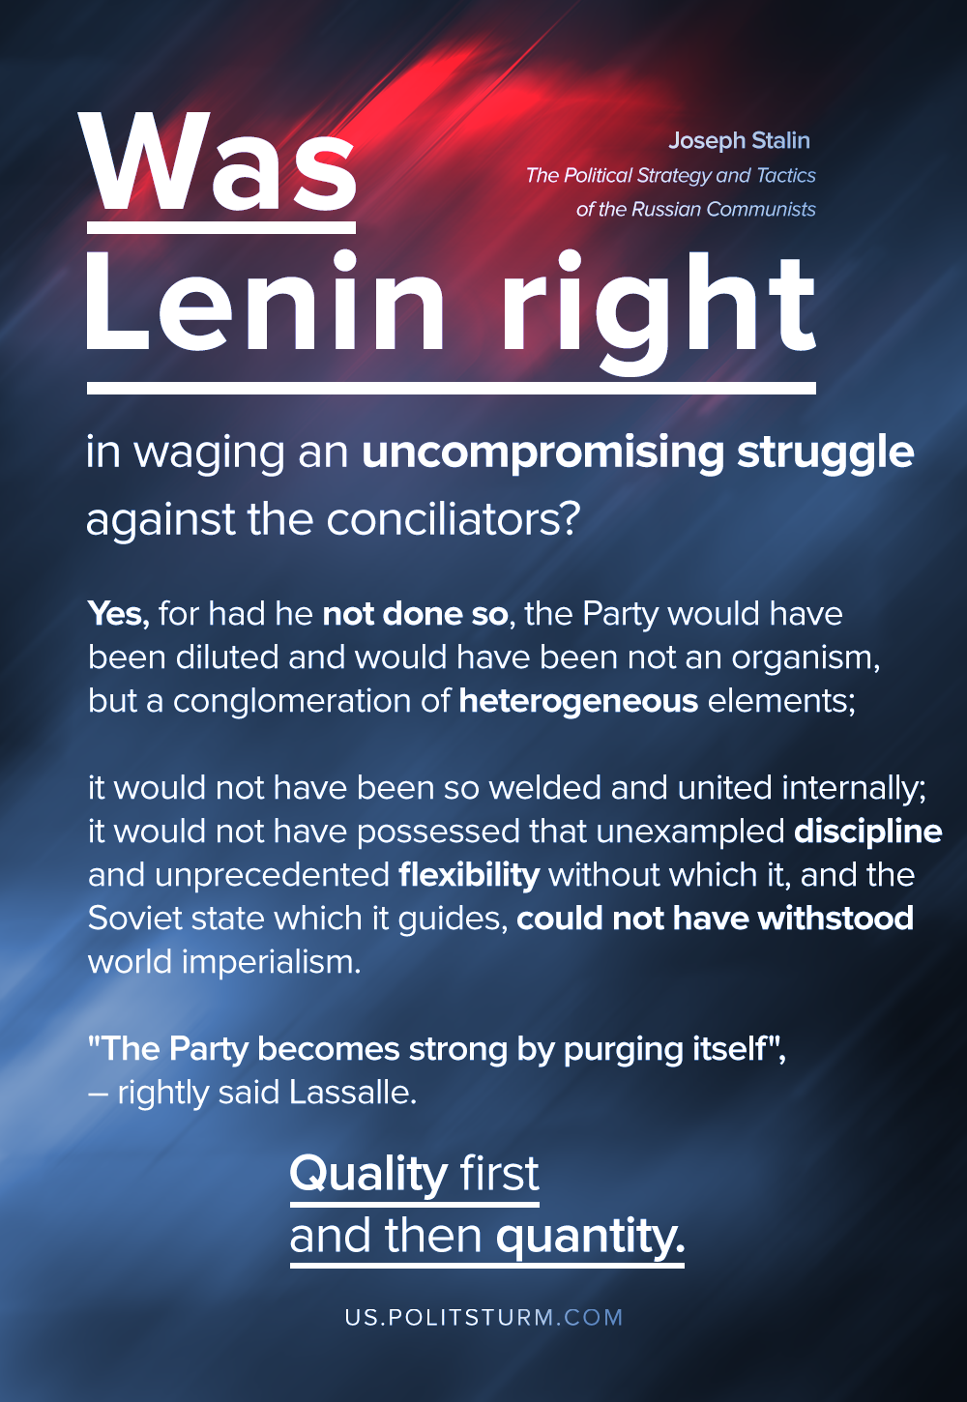

Original article
2020-08-30
1 min read

Was Lenin right in waging an uncompromising struggle against the conciliators? Yes, for had he not done so, the Party would have been diluted and would have been not an organism, but a conglomeration of heterogeneous elements; it would not have been so welded and united internally; it would not have possessed that unexampled discipline and unprecedented flexibility without which it, and the Soviet state which it guides, could not have withstood world imperialism. “The Party becomes strong by purging itself,” rightly said Lassalle. Quality first and then quantity.
J. V. Stalin “The Political Strategy and Tactics of the Russian Communists”

Original article

