Stalin on the Oil Problem
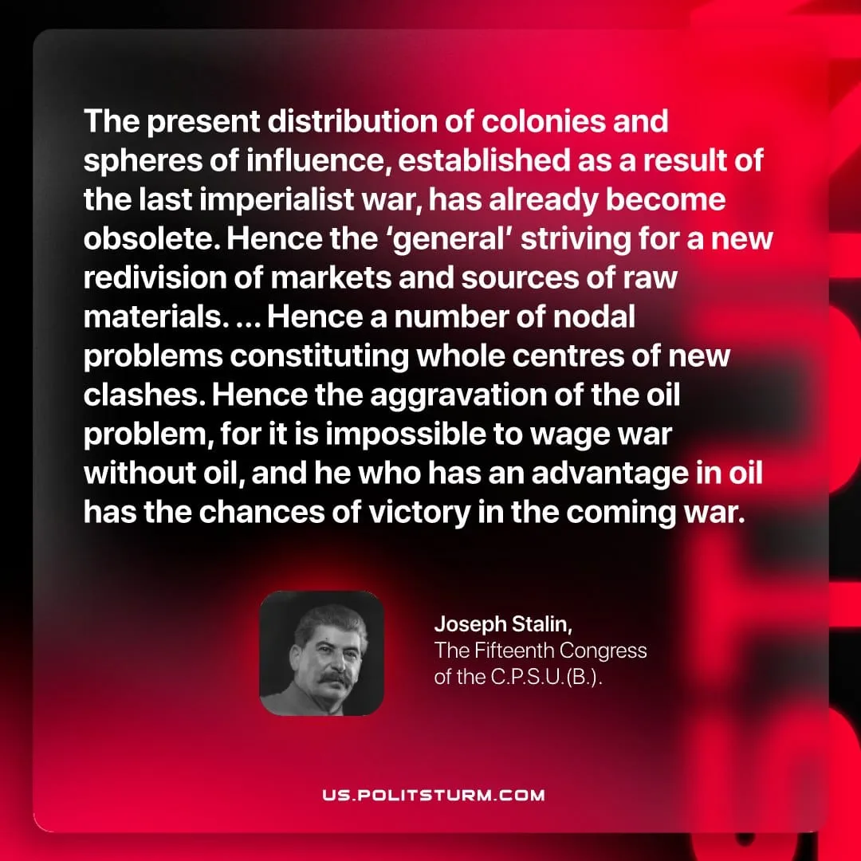

Original article
2026-05-12
1 min read

The present distribution of colonies and spheres of influence, established as a result of the last imperialist war, has already become obsolete. Hence the ‘general’ striving for a new redivision of markets and sources of raw materials. ... Hence a number of nodal problems constituting whole centres of new clashes. Hence the aggravation of the oil problem, for it is impossible to wage war without oil, and he who has an advantage in oil has the chances of victory in the coming war.
Joseph Stalin, The Fifteenth Congress of the C.P.S.U.(B.)

Original article

