Stalin on the October Revolution
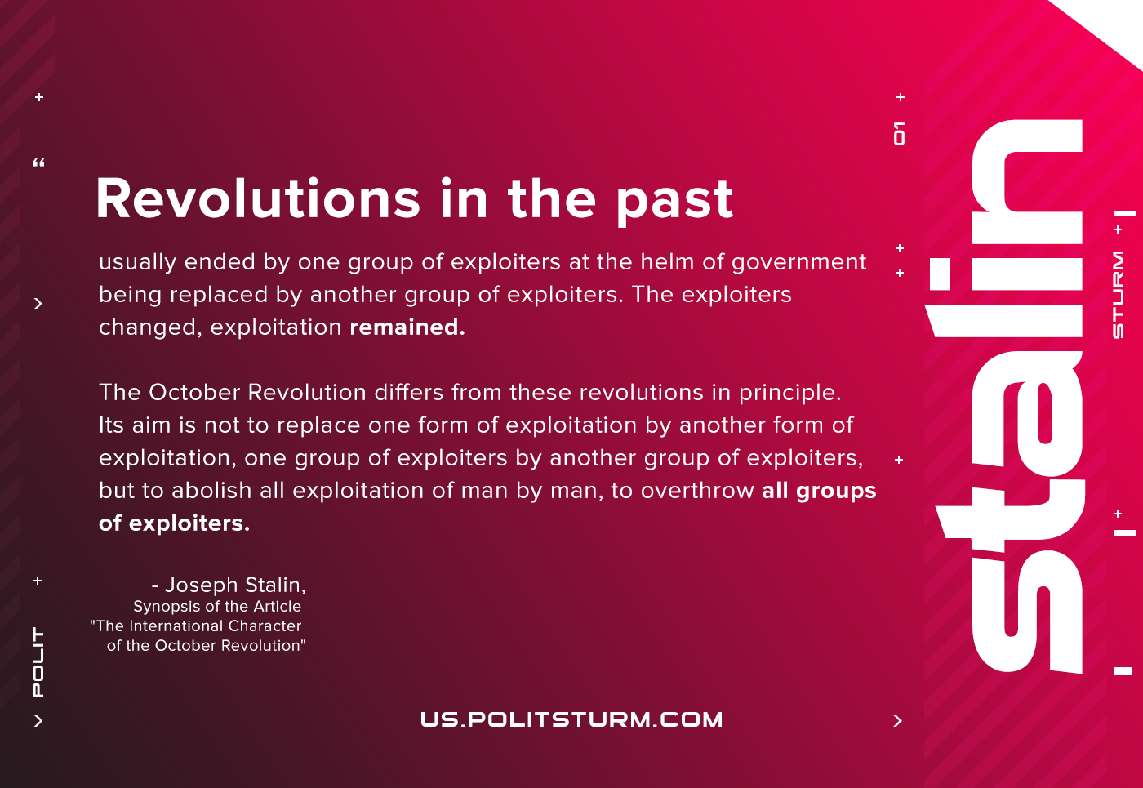

Original article
2020-11-07
1 min read

Revolutions in the past usually ended by one group of exploiters at the helm of government being replaced by another group of exploiters. The exploiters changed, exploitation remained. Such was the case during the revolutions of the slaves, the revolutions of the serfs, the revolutions of the commercial and industrial bourgeoisie. The October Revolution differs from these revolutions in principle. Its aim is not to replace one form of exploitation by another form of exploitation, one group of exploiters by another group of exploiters, but to abolish all exploitation of man by man, to overthrow all groups of exploiters.
Stalin, Synopsis of the Article “The International Character of the October Revolution”

Original article

