Stalin on the October Revolution and Imperialist Front
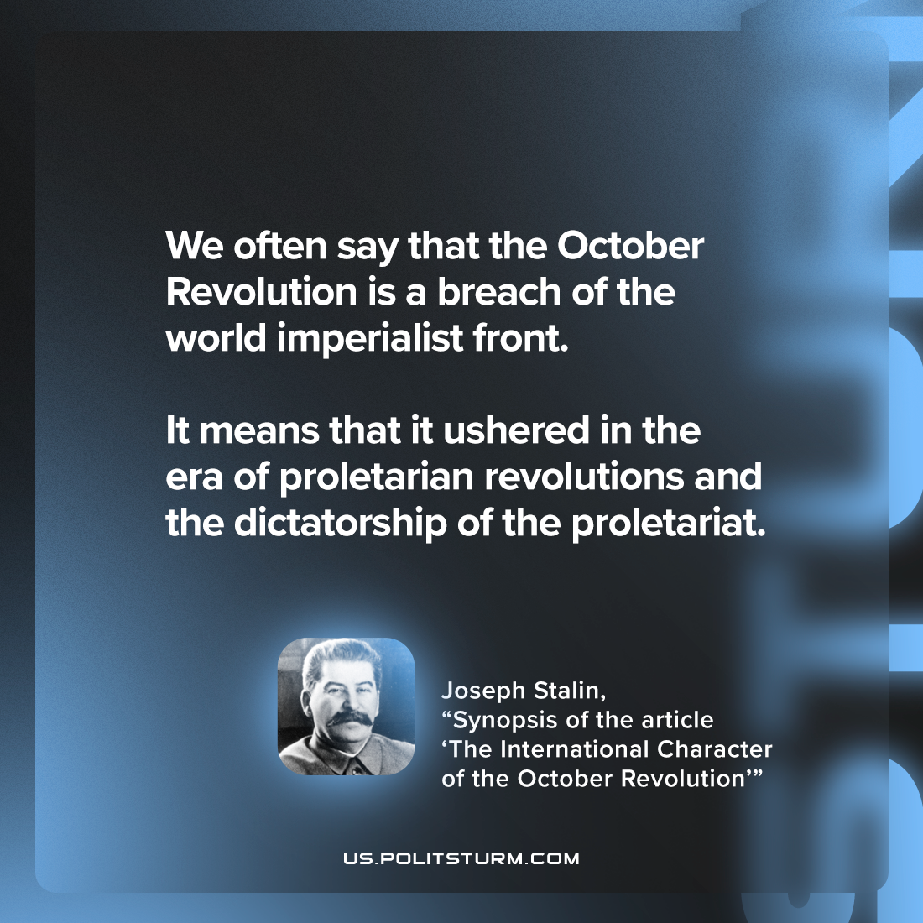

Original article
2022-12-27

"We often say that the October Revolution is a breach of the world imperialist front. But what does that mean? It means that it ushered in the era of proletarian revolutions and the dictatorship of the proletariat."
Joseph Stalin, 'Synopsis of the Article “The International Character of the October Revolution”'

Original article

