Stalin on the Need to Rise Up
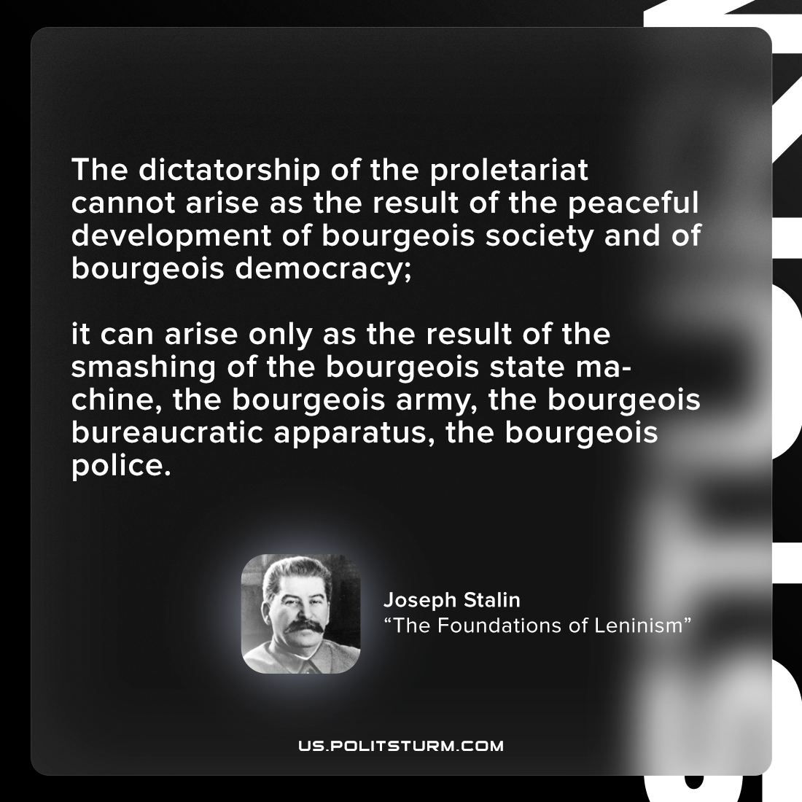

Original article
2022-06-20

The dictatorship of the proletariat cannot arise as the result of the peaceful development of bourgeois society and of bourgeois democracy;
it can arise only as the result of the smashing of the bourgeois state machine, the bourgeois army, the bourgeois bureaucratic apparatus, the bourgeois police.
Joseph Stalin, “The Foundations of Leninism”

Original article

