Stalin on the Need to Purge Opportunists From Organizational Ranks
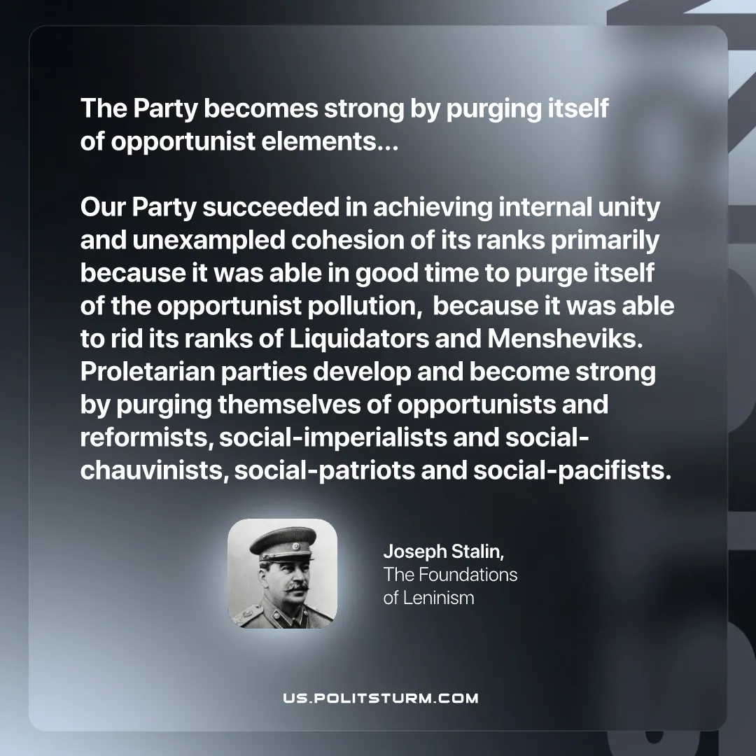

Original article
2026-01-04

"The Party becomes strong by purging itself of opportunist elements...Our Party succeeded in achieving internal unity and unexampled cohesion of its ranks primarily because it was able in good time to purge itself of the opportunist pollution, because it was able to rid its ranks of Liquidators and Mensheviks. Proletarian parties develop and become strong by purging themselves of opportunists and reformists, social-imperialists and social-chauvinists, social-patriots and social-pacifists. "
Joseph Stalin, “The Foundations Of Leninism”

Original article

