Stalin on the Necessity of Self‑Criticism
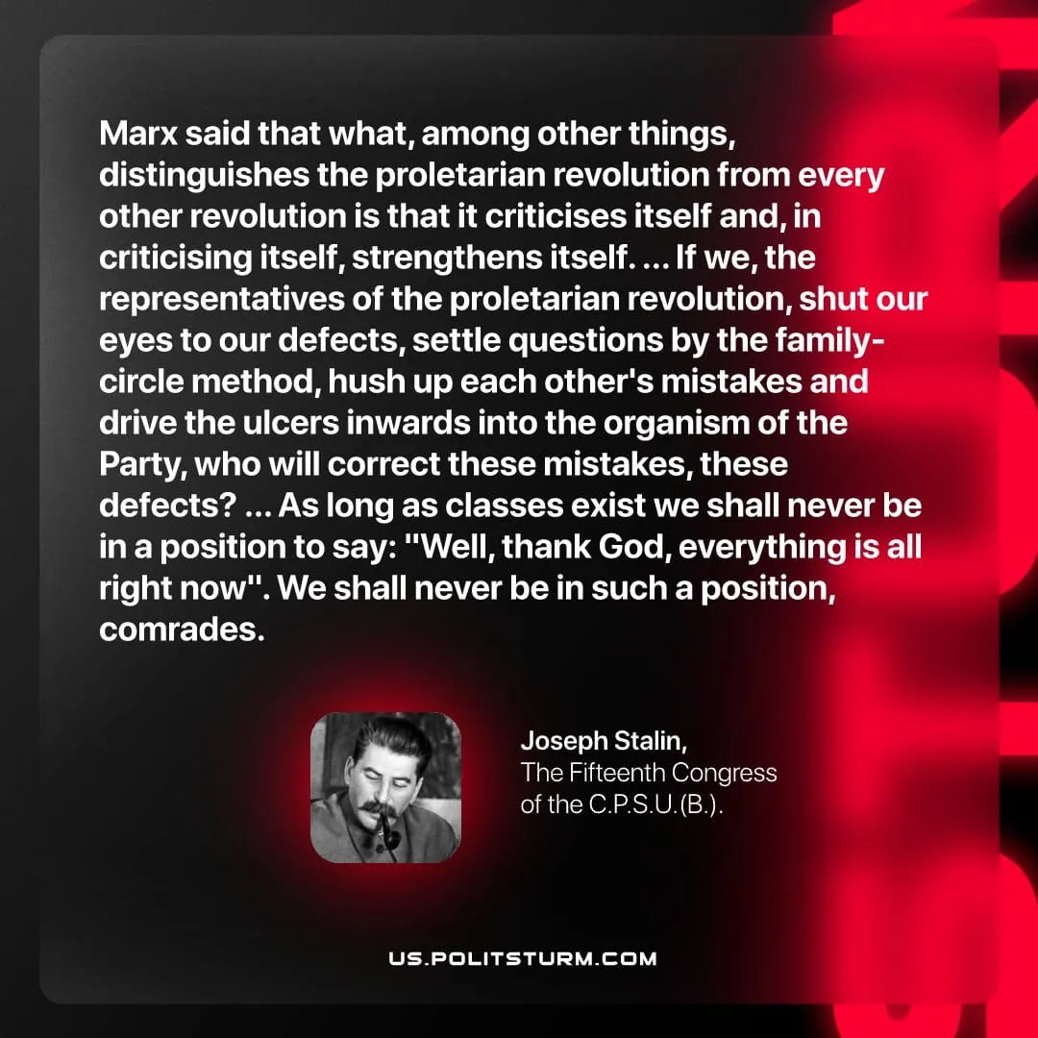

Original article
2026-05-19
1 min read

Marx said that what, among other things, distinguishes the proletarian revolution from every other revolution is that it criticises itself and, in criticising itself, strengthens itself. ... If we, the representatives of the proletarian revolution, shut our eyes to our defects, settle questions by the family-circle method, hush up each other's mistakes and drive the ulcers inwards into the organism of the Party, who will correct these mistakes, these defects? ... As long as classes exist we shall never be in a position to say: "Well, thank God, everything is all right now". We shall never be in such a position, comrades.
Joseph Stalin, The Fifteenth Congress of the C.P.S.U.(B.)

Original article

