Stalin on the "Middle Line"
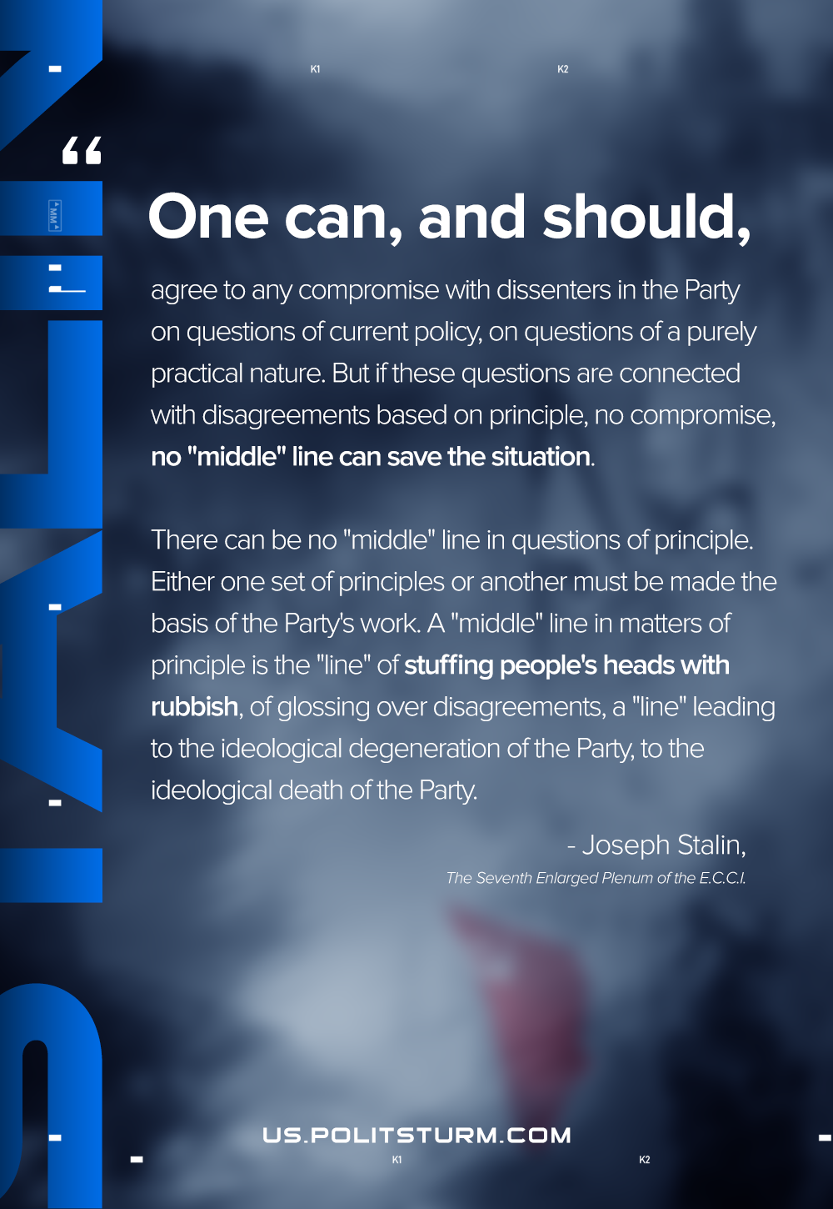

Original article
2020-12-08
1 min read

One can, and should, agree to any compromise with dissenters in the Party on questions of current policy, on questions of a purely practical nature. But if these questions are connected with disagreements based on principle, no compromise, no “middle” line can save the situation.
There can be no “middle” line in questions of principle. Either one set of principles or another must be made the basis of the Party’s work. A “middle” line in matters of principle is the “line” of stuffing people’s heads with rubbish, of glossing over disagreements, a “line” leading to the ideological degeneration of the Party, to the ideological death of the Party.
Joseph Stalin, The Seventh Enlarged Plenum of the E.C.C.I.

Original article

