Stalin on the Marxist Understanding of Equality
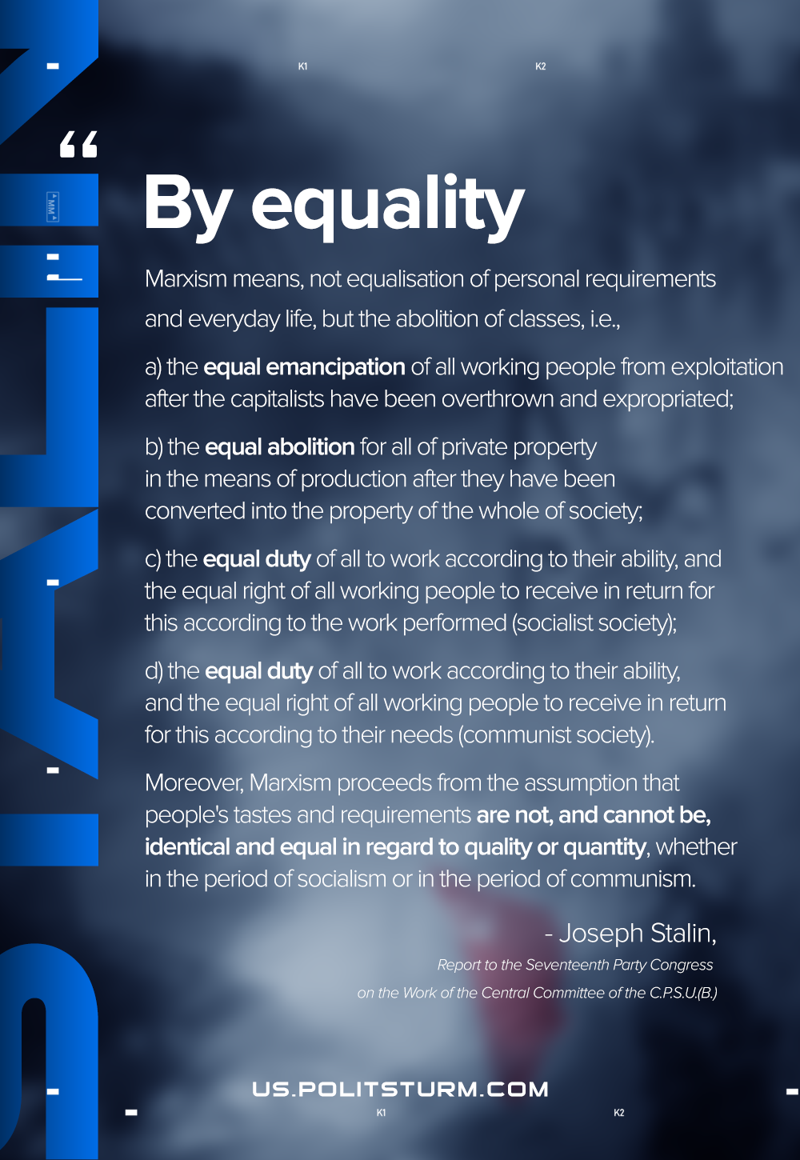

Original article
2020-12-11
1 min read

These people evidently think that socialism calls for equalisation, for levelling the requirements and personal, everyday life of the members of society. Needless to say, such an assumption has nothing in common with Marxism, with Leninism. By equality Marxism means, not equalisation of personal requirements and everyday life, but the abolition of classes, i.e., a) the equal emancipation of all working people from exploitation after the capitalists have been overthrown and expropriated; b) the equal abolition for all of private property in the means of production after they have been converted into the property of the whole of society; c) the equal duty of all to work according to their ability, and the equal right of all working people to receive in return for this according to the work performed (socialist society); d) the equal duty of all to work according to their ability, and the equal right of all working people to receive in return for this according to their needs (communist society). Moreover, Marxism proceeds from the assumption that people’s tastes and requirements are not, and cannot be, identical and equal in regard to quality or quantity, whether in the period of socialism or in the period of communism.
There you have the Marxist conception of equality.
Marxism has never recognised, and does not recognise, any other equality.
To draw from this the conclusion that socialism calls for equalisation, for the levelling of the requirements of the members of society, for the levelling of their tastes and of their personal, everyday life—that according to the Marxist plan all should wear the same clothes and eat the same dishes in the same quantity—is to utter vulgarities and to slander Marxism.
Joseph Stalin, Report to the Seventeenth Party Congress on the Work of the Central Committee of the C.P.S.U.(B.)

Original article

