Stalin on the Marxist Party
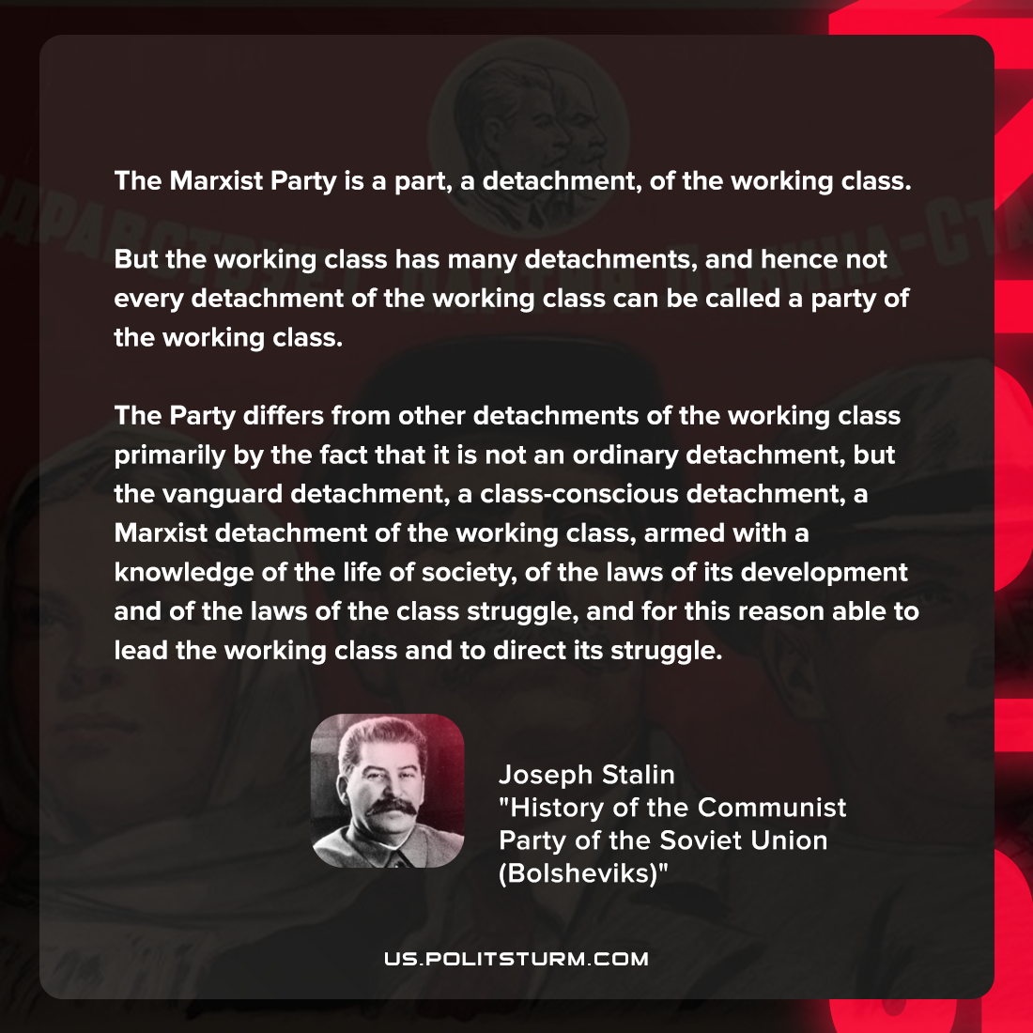

Original article
2022-04-26
1 min read

The Marxist Party is a part, a detachment, of the working class. But the working class has many detachments, and hence not every detachment of the working class can be called a party of the working class. The Party differs from other detachments of the working class primarily by the fact that it is not an ordinary detachment, but the vanguard detachment, a class-conscious detachment, a Marxist detachment of the working class, armed with a knowledge of the life of society, of the laws of its development and of the laws of the class struggle, and for this reason able to lead the working class and to direct its struggle.

Joseph Stalin, “History of the Communist Party of the Soviet Union (Bolsheviks)”

Original article

