Stalin on the Laws of Nature and Society
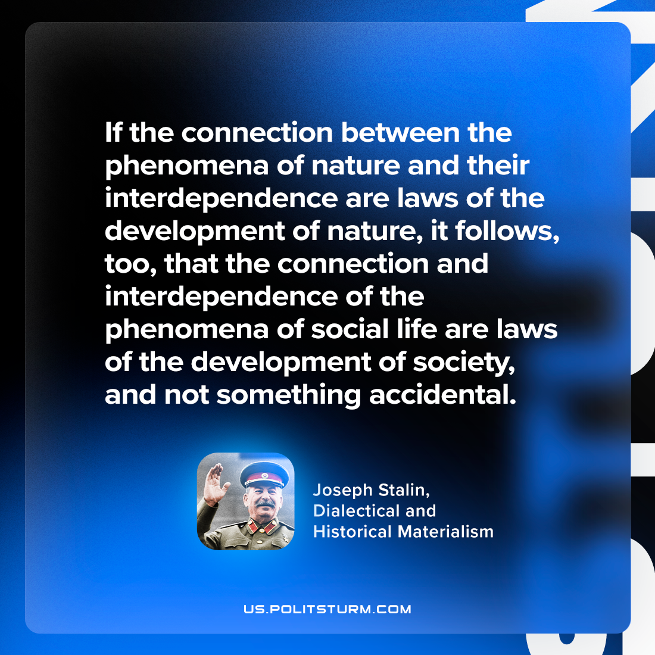

Original article
2024-06-04

"If the connection between the phenomena of nature and their interdependence are laws of the development of nature, it follows, too, that the connection and interdependence of the phenomena of social life are laws of the development of society, and not something accidental."
Joseph Stalin, Dialectical and Historical Materialism

Original article

