Stalin on the Laboring Masses Being the Driving Force of History
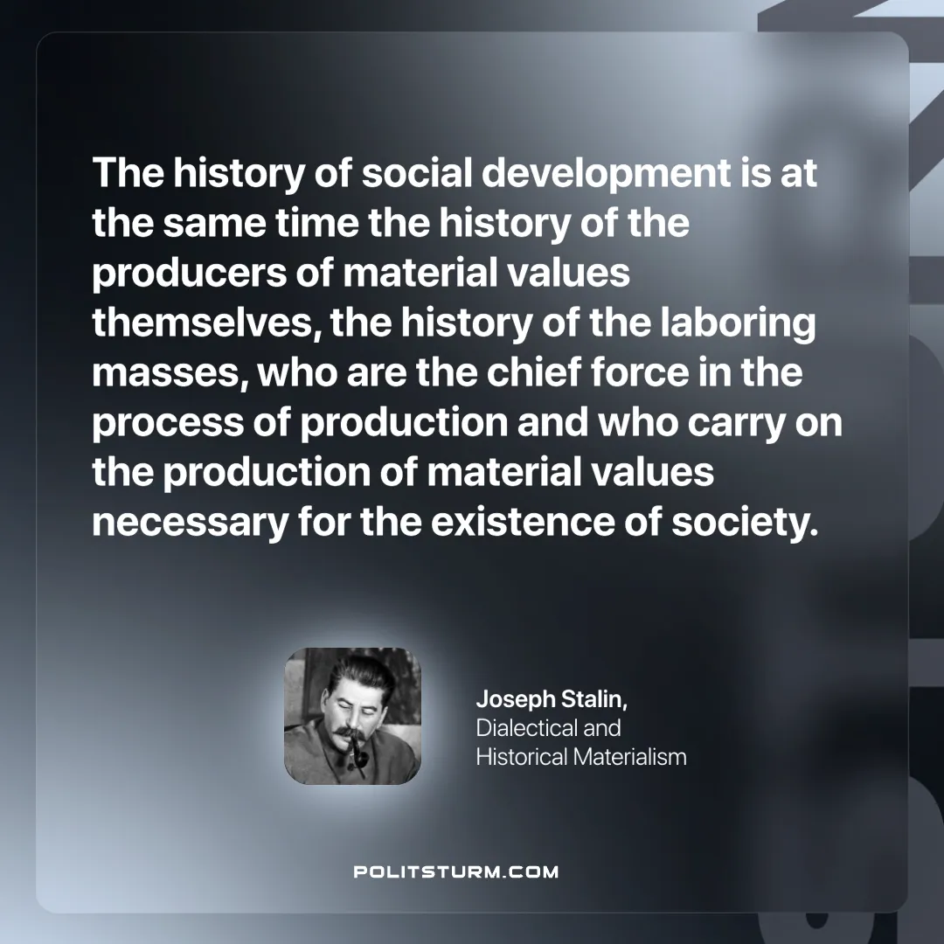

Original article
2025-01-19

“The history of social development is at the same time the history of the producers of material values themselves, the history of the laboring masses, who are the chief force in the process of production and who carry on the production of material values necessary for the existence of society.”
Joseph Stalin, Dialectical and Historical Materialism

Original article

