Stalin on the key to the National Question
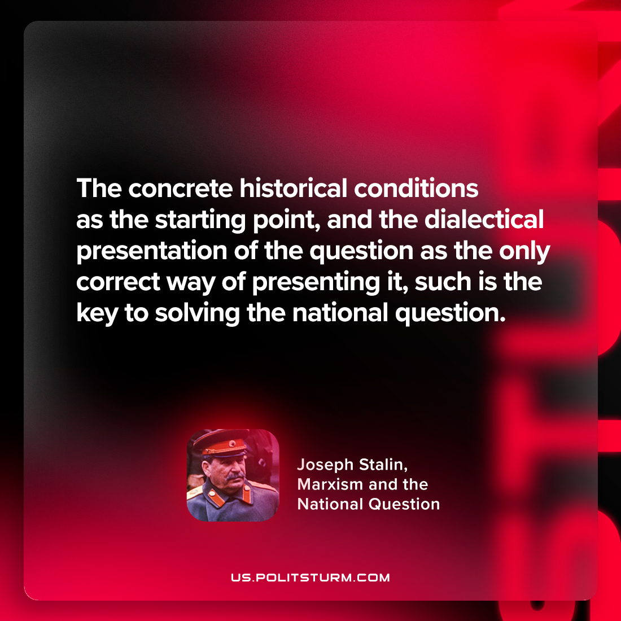

Original article
2024-06-09

"The concrete historical conditions as the starting point, and the dialectical presentation of the question as the only correct way of presenting it – such is the key to solving the national question."
Joseph Stalin, Marxism and the National Question

Original article

