Stalin on the International Army of Workers
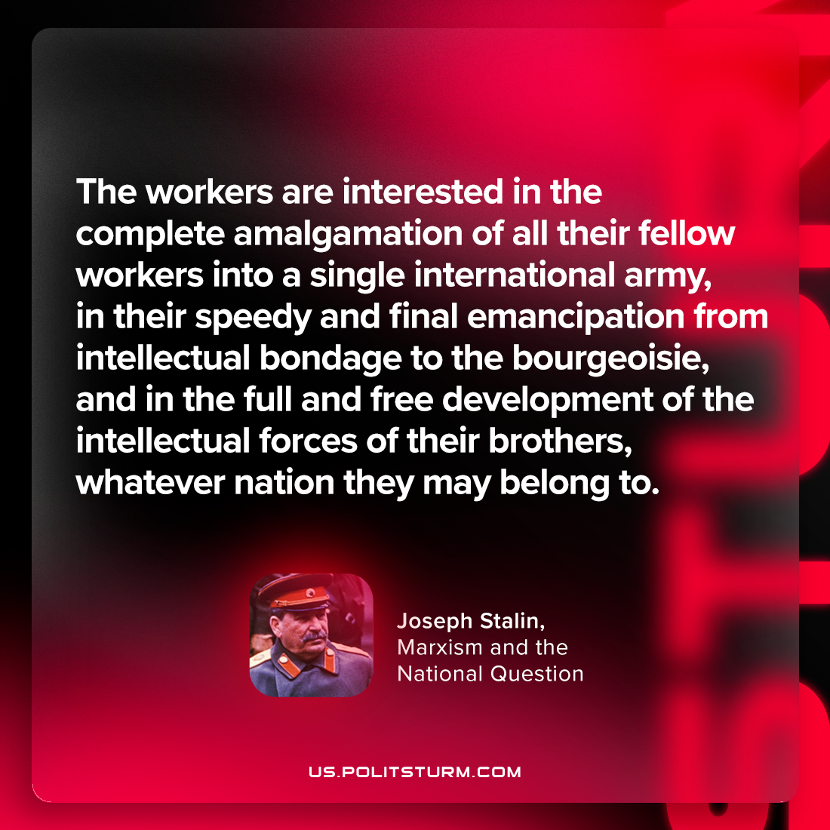

Original article
2024-04-11

“The workers are interested in the complete amalgamation of all their fellow-workers into a single international army, in their speedy and final emancipation from intellectual bondage to the bourgeoisie, and in the full and free development of the intellectual forces of their brothers, whatever nation they may belong to.”
Joseph Stalin, Marxism and the National Question

Original article

