Stalin on the Interests of the Proletarian and National Liberation Movement
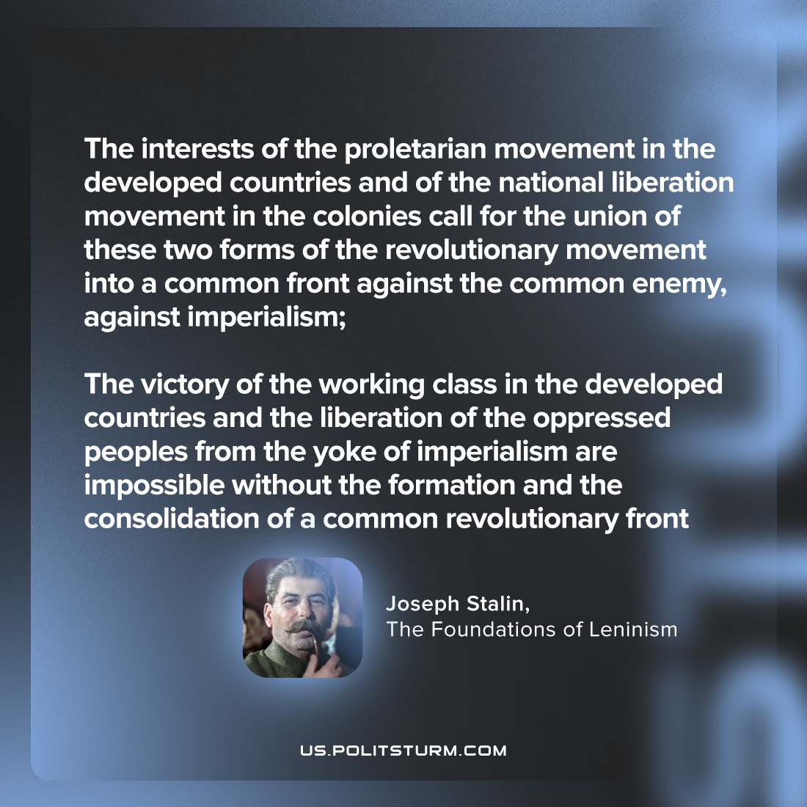

Original article
2023-07-04

"The interests of the proletarian movement in the developed countries and of the national liberation movement in the colonies call for the union of these two forms of the revolutionary movement into a common front against the common enemy, against imperialism; the victory of the working class in the developed countries and the liberation of the oppressed peoples from the yoke of imperialism are impossible without the formation and the consolidation of a common revolutionary front"
Joseph Stalin, The Foundations of Leninism

Original article

