Stalin on the Importance of Profit for the Capitalist
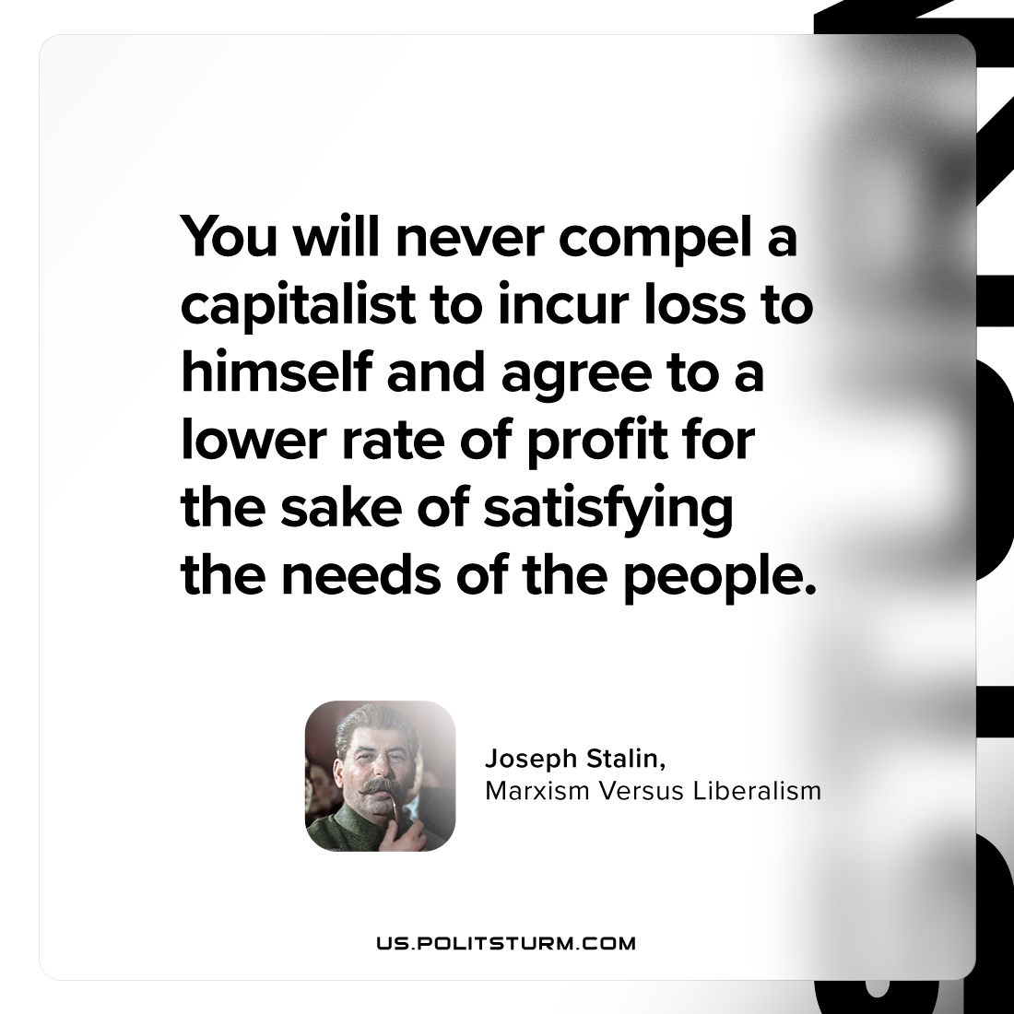

Original article
2023-09-03

"You will never compel a capitalist to incur loss to himself and agree to a lower rate of profit for the sake of satisfying the needs of the people."
Joseph Stalin, Marxism Versus Liberalism

Original article

