Stalin on the Imperialist System
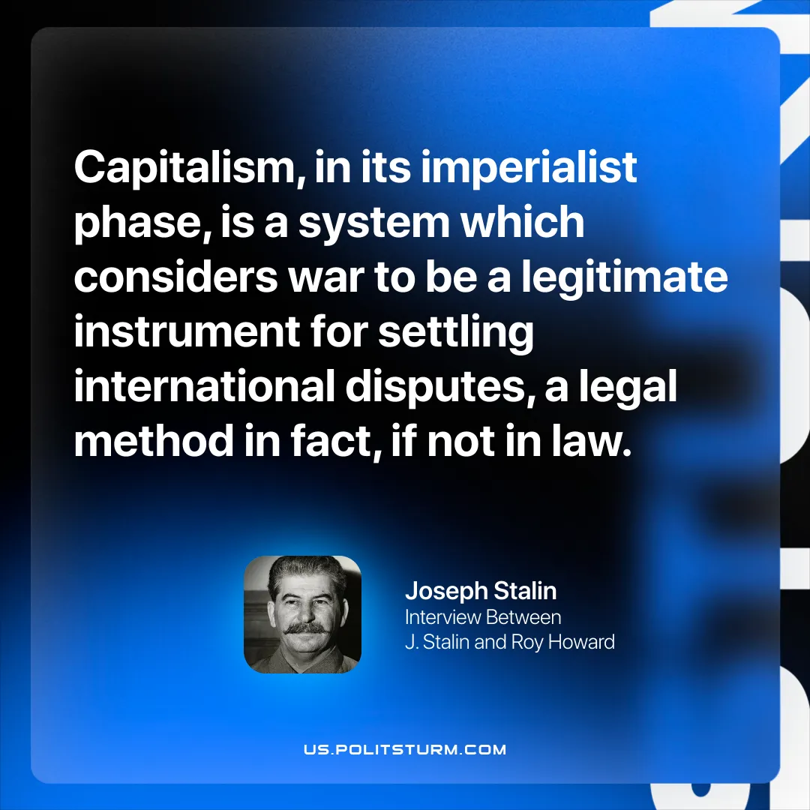

Original article
2026-04-05

“Capitalism, in its imperialist phase, is a system which considers war to be a legitimate instrument for settling international disputes, a legal method in fact, if not in law.”
Joseph Stalin, Interview Between J. Stalin and Roy Howard

Original article

