Stalin on the History of Development of Society
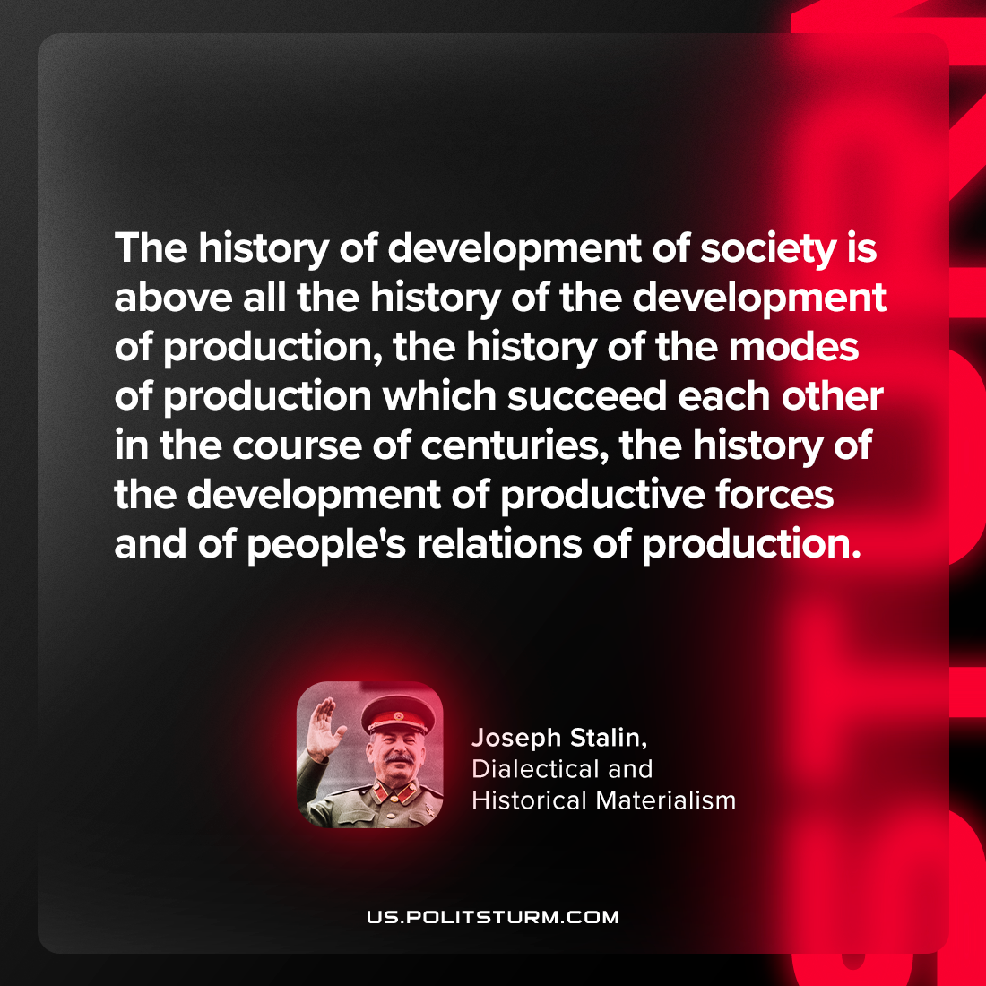

Original article
2024-01-07

"The history of development of society is above all the history of the development of production, the history of the modes of production which succeed each other in the course of centuries, the history of the development of productive forces and of people's relations of production."
Joseph Stalin, Dialectical and Historical Materialism

Original article

